Since the smart lock entered the Chinese market, convenience and safety have always been its biggest highlights after decades of ups and downs.
​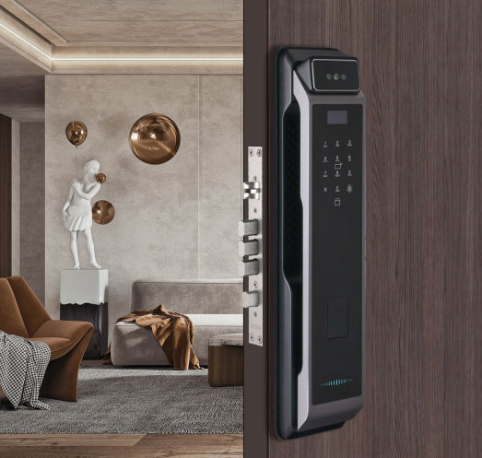
Later, with the continuous development of Internet of Things technology and technology, smart locks gradually introduced various functions and designs, and continued to evolve in a more "intelligent" direction on the basis of convenience and safety.
​
Today we will discuss and analyze these three highlights of smart locks in detail.

Safety
As the first security barrier to protect the home, door locks have always attracted people's attention for their safety. Therefore, being more secure than ordinary door locks has long been a highlight of smart locks.
​
From the initial password locks and fingerprint locks to face recognition locks and finger vein locks, new unlocking methods are constantly being introduced. But everything remains the same, and these unlocking methods are always evolving in a safer direction.
​
In addition to unlocking methods, many functions of smart locks also protect the security of home doors: the virtual password function effectively prevents password leakage; multiple alarm functions such as anti-pry alarm and trial and error alarm protect the safety of door locks at any time; the cat's eye video function will passively defend Switch to active defense and check the status of your home anytime and anywhere...

Therefore, the security of smart locks has always been one of its highlights. No matter how the functional technology of smart locks develops, it must be based on its safety and reliability.

Convenience
In the past, keys, wallet, and mobile phone were everyone’s three-piece set when going out. With the development of technology, mobile phones can gradually replace the function of wallets, and the three-piece set when going out has become two: mobile phone and keys. Later, with the development and popularity of smart lock technology, people can only bring their mobile phones when going out, without having to bring keys, which is very convenient.
​
The reason why many consumers buy smart locks is also because they don't need to carry a key when going out. It can be seen that "convenience" is also a highlight of smart locks.
​
At the same time, various unlocking methods such as fingerprints, passwords, faces, and finger veins can meet the different daily unlocking needs of different groups of people, solve the different unlocking pain points of consumers, and achieve truly light travel.
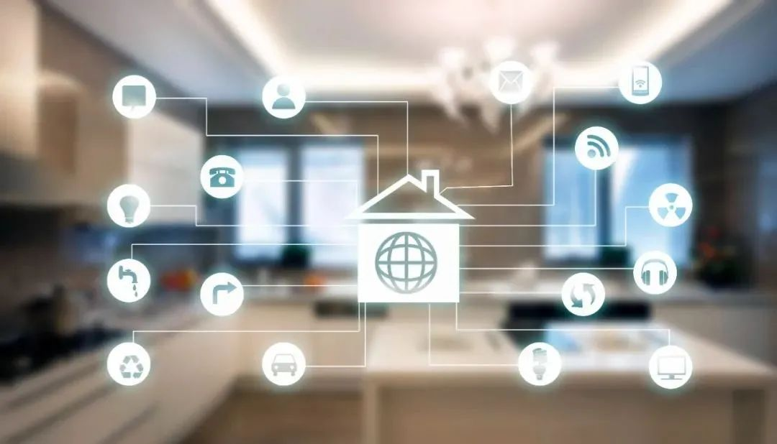
Intelligent
In the early days of development, smart locks generally only had unlocking functions such as fingerprints and passwords, and did not have other "intelligent" functions. With the continuous development of Internet of Things technology, especially after entering the smart home era, smart locks are not just a simple lock, but become more and more "smart".
​
Take networked locks as an example. Smart locks at this stage can generally be managed on a mobile phone APP. Users can monitor the door lock status at any time. If there are special circumstances such as the door being broken open or multiple trials and errors, the APP will send an alarm directly through the mobile phone. Information informs users to protect home security more intelligently. In addition, many smart locks can also be intelligently linked with smart homes, making smart locks truly smart.

At this stage, many technical functions of smart locks are very mature, and their safety and convenience can be well guaranteed. Users no longer need to worry about home security and travel convenience. Therefore, the intelligent highlights of smart locks have become the focus of consumers, especially young people.

In recent years, smart lock products have been constantly introducing new ones. The seemingly diverse functions and designs are actually inseparable from the three basic highlights of "safety", "convenience" and "smartness", because these are the most basic requirements for smart lock products for consumers. demands and expectations. It is hoped that various smart lock brands will not put the cart before the horse and pile up many "gimmick" functions, but return to the essence of smart locks and develop truly safe, convenient and intelligent smart locks for consumers.

