When it comes to smart door locks, everyone is familiar with them. You don’t need to bring a key when you go out, which solves the daily trouble of forgetting to bring your keys. Its multiple unlocking methods can meet the needs of different family members. This is why more and more people are installing them at home. The main reason for smart locks is that when users decorate their new homes and build smart homes, they will choose smart locks, smart cat eyes, and smart doorbells. Each of the three products needs to be installed separately and the APP is bound to the device. Is it troublesome? A three-in-one smart lock that integrates door locks, doorbells, and peepholes allows you to install one product and achieve door security in one step.

Fuyu's fully automatic smart door lock packaging box is high-end and elegant, and the black color looks high-end. It makes reasonable use of the packaging space and uses pearl cotton to perfectly protect the product. Beauty is atmosphere.
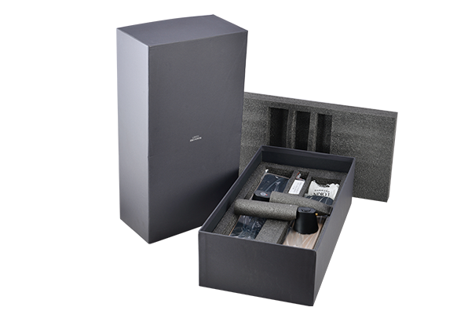
Inside the package, there are independent small packages containing the front and rear panels, the lock body and other accessories.

The panel of Fuyu fully automatic smart door lock is divided into two parts: the front panel and the rear panel. The factory panels are all affixed with protective stickers to prevent scratches on the panels during installation.

The front panel of Fuyu's fully automatic smart door lock has a smart camera on the top. The camera uses a wide-angle camera to capture a wider and clearer picture, effectively reducing the blind area.

Users who use smart password locks will be worried. What if the password lock cannot open the door due to lack of power, invalid fingerprint, etc.? Fuyu’s smart lock supports emergency key unlocking method. There is a mechanical keyhole on the front panel. Under the panel, press the keyhole cover. After the cover is lifted, you can insert the key into the keyhole to unlock.

The Fuyu fingerprint recognition module is set on the front. The fingerprint module uses a multi-dimensional semiconductor fingerprint module. The fingerprint recognition rate is as high as 98%, and the recognition rate is very high for the elderly and children.
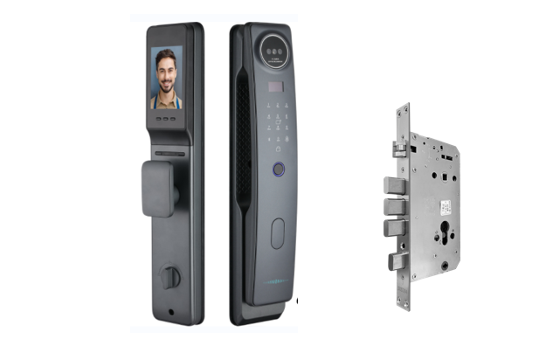

There is an emergency power supply interface at the bottom of the front panel. The power supply interface adopts the current mainstream Type-C interface. You don’t have to worry about the front and back of the plug. It’s plug and play. When the battery is out of power and cannot open the door, the user can use the mobile power source to provide emergency power to open the door.

Fuyu fully automatic smart door lock has 5 methods including fingerprint unlocking, password unlocking, card, APP unlocking, temporary password unlocking, and emergency key unlocking. The most commonly used method in daily life is fingerprint unlocking.

When the fingers are peeling or there are elderly people at home whose fingerprints are unclear, using fingerprints to open the door is not effective. You can use a password to unlock the door. In order to prevent others from seeing the password, users can use a dummy password to effectively prevent others from peeping and remembering the password.

To open the door indoors, just press the door open button to quickly unlock it. When the door is closed, the lock body automatically locks and comes with a voice prompt, so you no longer have to worry about whether the elderly at home have locked the door when they go out.

