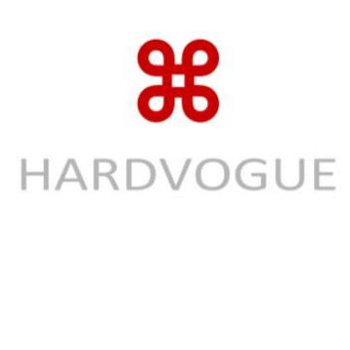 **White IML Film**

(HWCMP62-103) 2025/ 03/ 02

1. **Product Overview & Applications**

White IML film is a high-quality, biaxially oriented polypropylene film designed for in-mold labeling applications. The white finish provides a clean, crisp appearance ideal for a variety of products. Common applications include:

- Food packaging: ready-to-eat meals, snacks, dairy products

- Beverage containers: cups, bottles, and cans

- Consumer goods: cosmetics, household products

- Pharmaceutical packaging

1. **Technical Specifications**

|  |  |  |  |  |  |
| --- | --- | --- | --- | --- | --- |
| **Property** | **Unit** | **50µm** | **60µm** | **70µm** | **80µm** |
| Thickness | µm | 60±3 | 65±3 | 70±3 | 80±3 |
| Tensile Strength (MD/TD) | N/15mm | ≥30/15 | ≥35/18 | ≥40/20 | ≥45/22 |
| Opacity | % | ≥90 | ≥90 | ≥90 | ≥90 |
| Gloss (60°) | GU | ≥80 | ≥80 | ≥80 | ≥80 |
| Moisture Barrier | - | Good | Good | Good | Good |
| Heat Resistance | °C | Up to 120 | Up to 120 | Up to 120 | Up to 120 |
| Surface Tension | mN/m | ≥38 | ≥38 | ≥38 | ≥38 |
| Print Compatibility | - | Flexo, Offset, Rotogravure,Digital | Flexo, Offset, Rotogravure,Digital | Flexo, Offset, Rotogravure,Digital | Flexo, Offset, Rotogravure,Digital |

**3. Additional Features 4. Storage & Handling**

- White finish for premium, high-contrast labels. - Store in a dry, cool area (10–25°C, 40–60% RH).

- Excellent durability and resistance to moisture and chemicals. - Avoid direct sunlight, extreme humidity, and high temperatures.

- Highly suitable for both cold and hot applications. - Store flat and protect from contamination, dust, and physical damage.

- Compatible with various printing technologies for branding.

- Recyclable and eco-friendly material options available.

Hardvogue Limited Address: Xixi Shouzuo, Wenyi Road, West Lake District, Hangzhou City, China 310030 Email: sales@hardvogueltd.com Website: www.hardvogue.com