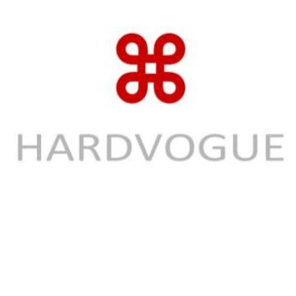 **Transparent IML Film**

(HWCMP62-105) 2025/ 03/ 02

1. **Product Overview & Applications**

Transparent In Mold Label Film is a high-quality, transparent film designed for in-mold labeling applications. It provides excellent clarity and durability, making it an ideal solution for product packaging where visibility is important. It is commonly used for labeling plastic containers, food packaging, and cosmetic products. Common applications include:

- Food containers (snacks, dairy, and beverages)

- Cosmetic packaging (bottles, jars, and tubes)

- Household products (detergent bottles, cleaning supplies)

- Pharmaceutical packaging

**2. Technical Specifications**

|  |  |  |  |  |  |
| --- | --- | --- | --- | --- | --- |
| **Property** | **Unit** | **50µm** | **60µm** | **70µm** | **80µm** |
| Thickness | µm | 60±3 | 65±3 | 70±3 | 80±3 |
| Tensile Strength (MD/TD) | N/15mm | ≥30/15 | ≥35/18 | ≥40/20 | ≥45/22 |
| Transparency | % | ≥90 | ≥90 | ≥90 | ≥90 |
| Gloss (60°) | GU | ≥80 | ≥80 | ≥80 | ≥80 |
| Moisture Barrier | - | Good | Good | Good | Good |
| Heat Resistance | °C | Up to 120 | Up to 120 | Up to 120 | Up to 120 |
| Surface Tension | mN/m | ≥38 | ≥38 | ≥38 | ≥38 |
| Print Compatibility | - | Flexo, Offset, Rotogravure,Digital | Flexo, Offset, Rotogravure,Digital | Flexo, Offset, Rotogravure,Digital | Flexo, Offset, Rotogravure,Digital |

**3. Additional Features 4. Storage & Handling**

- Excellent transparency and clarity for product visibility. - Store in a dry, cool area between 10°C and 30°C.

- Good barrier properties against moisture and light. - Avoid direct sunlight, excessive humidity, and temperature fluctuations.

- Strong tensile strength for durable packaging. - Keep flat and protect from contamination and physical damage.

- Suitable for both food-safe and non-food packaging.

- Recyclable and environmentally friendly material.

Hardvogue Limited Address: Xixi Shouzuo, Wenyi Road, West Lake District, Hangzhou City, China 310030 Email: sales@hardvogueltd.com Website: www.hardvogue.com