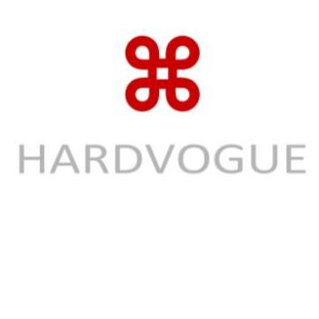 **Metallized BOPP Film**

(HWCMP62-104) 2025/ 03/ 02

**1. Product Overview & Applications**

Metallized BOPP film is a high-performance packaging material with a metallized layer that provides a shiny, reflective surface. It is used in a variety of applications where an attractive appearance and functional performance are required. Common applications include:

- Flexible packaging for snacks, confectionery, and beverages

- Decorative packaging for gift items and luxury goods

- Pharmaceutical and personal care product packaging

- Tamper-evident seals and security packaging

1. **Technical Specifications**

|  |  |  |  |  |  |
| --- | --- | --- | --- | --- | --- |
| **Property** | **Unit** | **50µm** | **60µm** | **70µm** | **80µm** |
| Thickness | µm | 60±3 | 65±3 | 70±3 | 80±3 |
| Aluminum Coating Thickness | nm | 30-50 | 30-50 | 30-50 | 30-50 |
| Tensile Strength (MD/TD) | N/15mm | ≥30/15 | ≥35/18 | ≥40/20 | ≥45/22 |
| Gloss (60°) | GU | ≥80 | ≥80 | ≥80 | ≥80 |
| Opacity | % | ≥90 | ≥90 | ≥90 | ≥90 |
| Heat Resistance | °C | Up to 180 | Up to 180 | Up to 180 | Up to 180 |
| Surface Tension | mN/m | ≥38 | ≥38 | ≥38 | ≥38 |
| Moisture Barrier | - | Excellent | Excellent | Excellent | Excellent |

**3. Additional Features 4. Storage & Handling**

- High gloss finish and metallic appearance for premium shelf appeal. - Store in a dry, cool place between 10°C and 30°C.

- Excellent barrier properties against moisture, light, and oxygen. - Keep away from direct sunlight and humidity.

- Compatible with flexographic, gravure, and offset printing for branding. - Store in original packaging until use to prevent contamination and damage.

- Strong mechanical properties for durability in packaging.

- Recyclable and available with eco-friendly coatings.

Hardvogue Limited Address: Xixi Shouzuo, Wenyi Road, West Lake District, Hangzhou City, China 310030 Email: sales@hardvogueltd.com Website: www.hardvogue.com