**3D Holographic Fan Display**

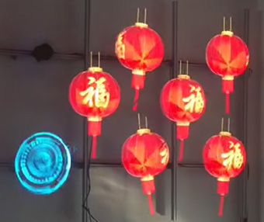

ITATOUCH has the professional 3d holographic display technology, which equips with the remote control software, user can publish / send the advertising information contents, as video, image, words by mobile phone, computer, ipad, android tablet ... mobile terminal. include power on / off the display .

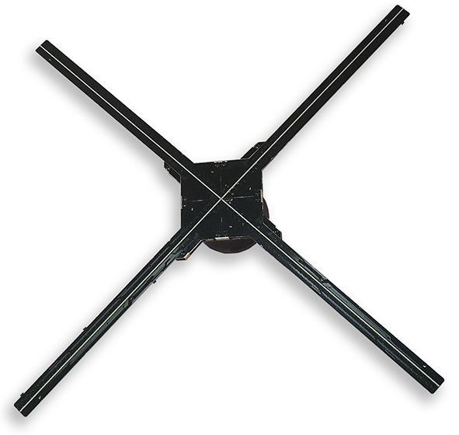

The hologram fan software compatible with android os, mac os, windows os.

It is built-in android 7.1 os, arm quad-core 1.5g processor 8gb storage.

It is applied to the advertising industry, such as: Launching Ceremony, Cultural And Entertainment Performances, Annual Meeting Activities, New Product Launch, Large Amusement Places, Wedding Venues, Real Estate Sand Table, Physical Stores, Shopping Malls, Airports, Auto Shows, Exhibitions, Chain Stores, Window, Museums, Catering and Entertainment Industries, etc

**Details Picture:**

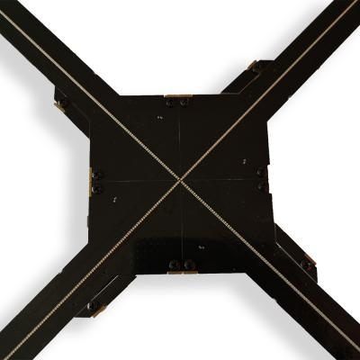 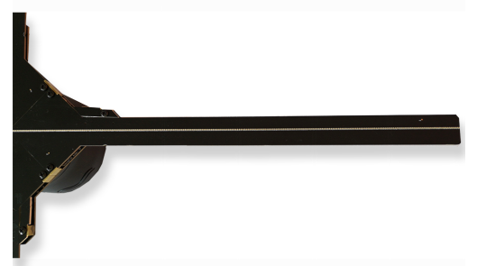

High density light beads with high definition, even in sunshine it's Bright and Visible.

**Specification:**

|  |  |  |
| --- | --- | --- |
| **Display Technology** | | |
| Model# | M6 | X4 |
| Display size | 65CM | 75CM |
| Blades | 4pieces | 4pieces |
| LED Light Beads | - | 256*4 |
| Max Resolution | 872*872 | 1024*1024; Splicing Display: 4096*4096 |
| Brightness | 2500cd/m2 | 1900cd/m2 |
| Frame rate | 24 frame/sec | 24 frame/sec |
| Display Angle | 176 degree | 176 degree |
| Permeability Rate | 92% | 92% |
| Noise | 50Db（with the cover protection） | 55Db（with the cover protection） |
| Lifetime | 30000hours | 30000hours |
| **Android System** | | |
| Running OS | Android 7.1 | Android 7.1 |
| CPU | ARM Quad-core 1.5G Processor | ARM Quad-core 1.5G Processor |
| Storage | 8GB | 16GB |
| Control method | Wi-Fi（2.4G） | Wi-Fi（2.4G） |
| Audio output | Support Bluetooth | Support Bluetooth |
| Compatible OS | Support IOS, Android | Support Windows, IOS, Android |
| Video Format | Support JPG GIF MP4 AVI RMVD MPEG | Support JPG GIF MP4 AVI RMVD MPEG |
| Video background | image & video（black background ） | image & video（black background ） |
| **Working Environment** | | |
| Max Power supply | 120W 24V | 120W 24V |
| Input Volt | 100-240VAC,50/60HZ | 100-240VAC,50/60HZ |
| Environment Temperature | -30~60℃ | -30~60℃ |
| **Physical Attribute** | | |
| Color | Black | Black |
| Materials | ABS+PC/AL | ABS+PC/AL |
| Products Dimension | 65cm*65cm*7cm | 70cm*70cm*7cm |
| Weight | 0.70KG | 0.78KG |
| Package Accessories | Wall Mount *1, Adapter *1， Power Cable*1 | Wall Mount *1, Adapter *1， Power Cable*1 |
| Package Dimension | - | 565*125*565mm /pcs; 585*525*585mm/4pieces |
| Quality Compliance | CE, FCC, ROHS, ISO9001 | CE, FCC, ROHS, ISO9001 |
| **Function & Advantages** | | |
| Application | Indoor, Outdoor (with the protected cover） | Indoor, Outdoor (with the protected cover） |
| Control Method | APP control; : Point-to Ppoint , Network Remote Control; Clustering, Live Broadcast | APP & Windows Software : Point-to Ppoint , Network Remote Control; Clustering, Live Broadcast, Splicing - Windows OS |

**75cm Dimensions:**

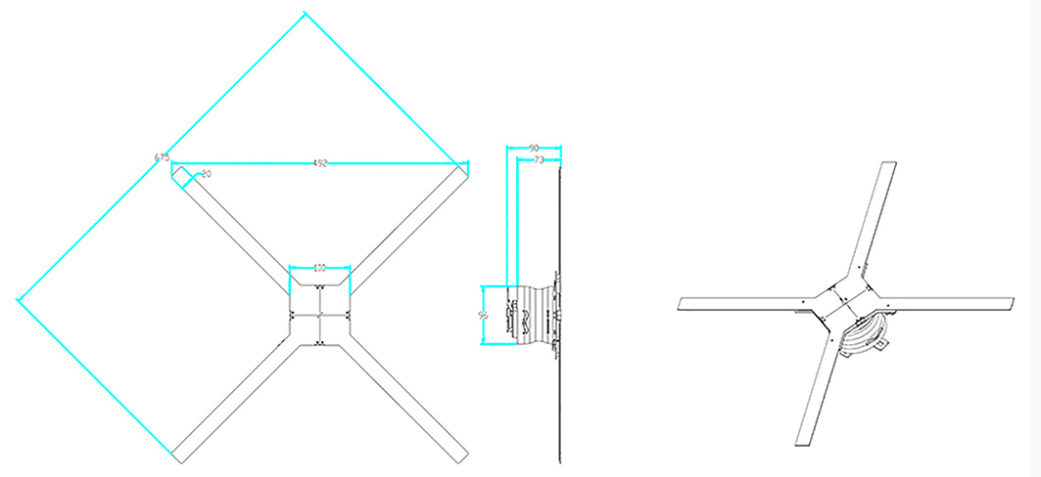

Advantage:

1. Wireless WIFI, one key upload by APP.

2. HD display with minimum spacing led, which the effect is same as led screen P0.7 series

3. High brightness 1900nits ~2500nits, sunshine visible

4. High resolution for 75cm - 1024*1024; The spliced display resolution can reach 4096*4096

5. Real-time uploading by APP & Windows Software/Splicing, and simple and easy debugging6. Remote control can upload the advertising video & content from a distance, even at home.

7. ITATOUCH professional R & D team, support OEM | ODM, Customized product. Non-worry Service

**Splicing Solutions:**

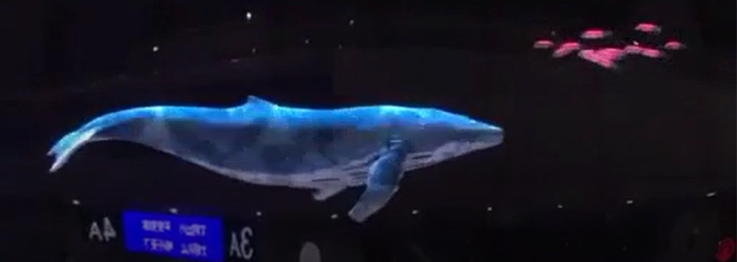

**This is a splicing solution 3*2 holographic fan**

**.**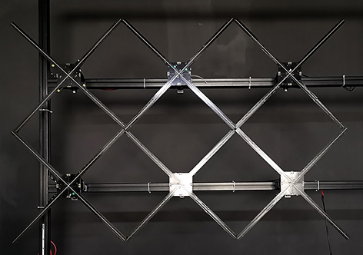

**The installation by the stand - customized per the splicing pieces**

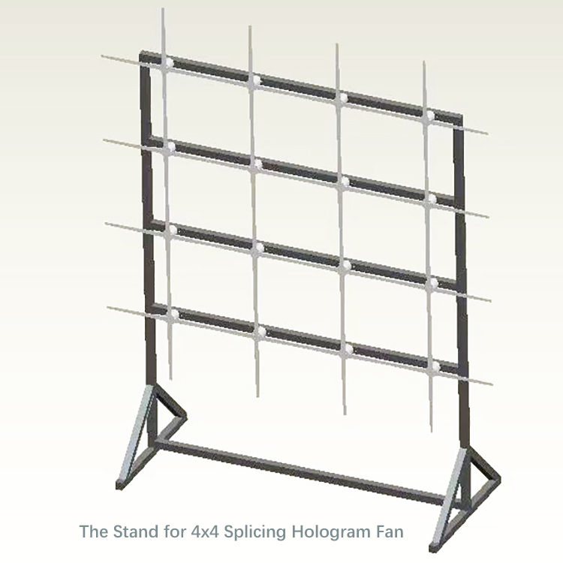

**Requirements of the Splicing Installation Windows OS**

Running System Requirements for 3D Hologram Fan Splicing Screens

Computer: Above E5 CPU, Storage：>= 64GB SSD RAM：16GB DDR3 or above

Operation System：Windows 7 above

Router: It had to be TPlink-AC1900, which one could be connected with 20 pieces of holographic advertising display, and free adjust the position of every hologram fan what you need.

Installed The Management Software for 3D Digital Adverting Fan

Program name: HoloPlayer.msi

**User can remote publish any information content by PC to manage all hologram fans.**

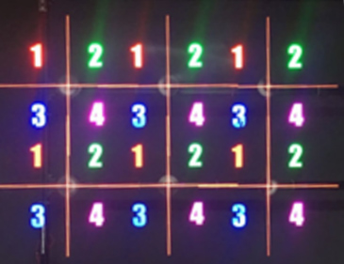 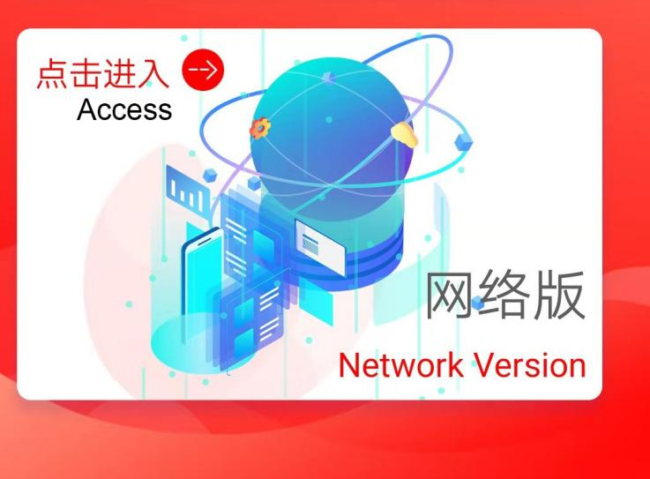

Splicing Permutation Matrix Management Software

**The 3D hologram fan with The Transparent Cover Showcase:**

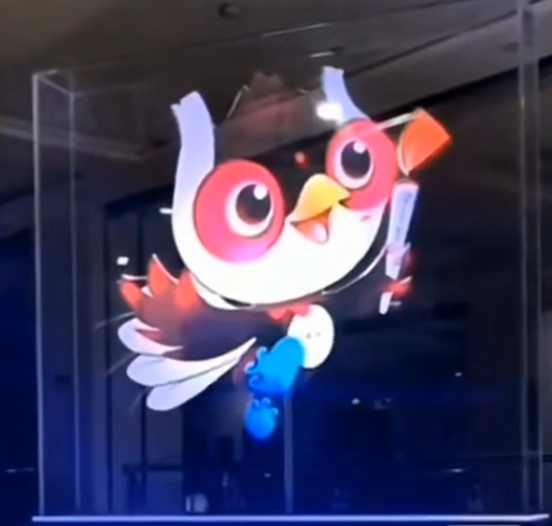

**Package:**

