**19" Desk All In One PC**

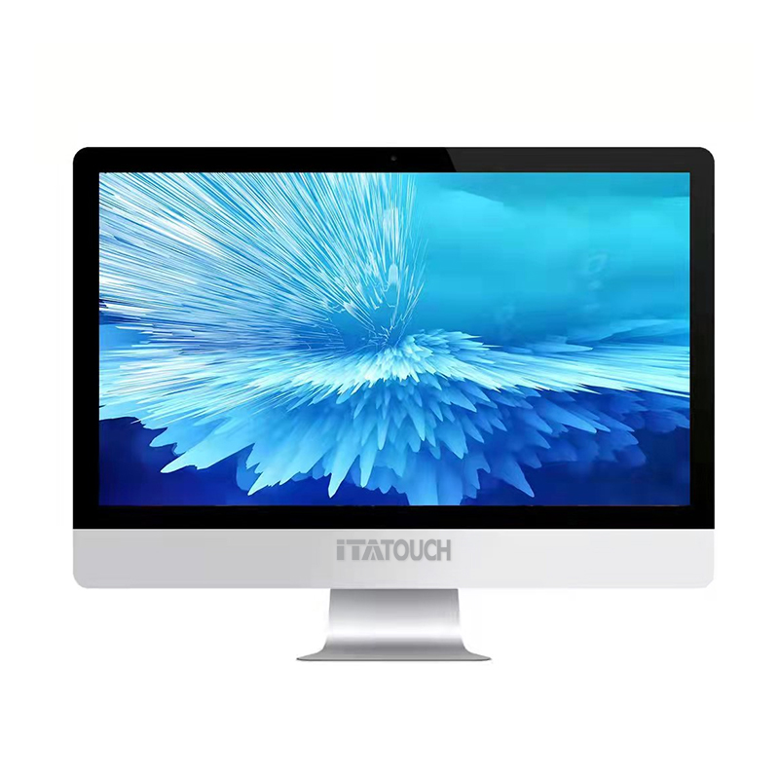

**Apple Style, Aluminum Shell, Perfect Finish**

**Application :**

It is widely used in offices, schools, hotels, airports, stations ... etc , which it offers people a free and convenient working, teaching and learning.

1. **Optional Configuration**

**SSD**

**RAM**

**CPU**

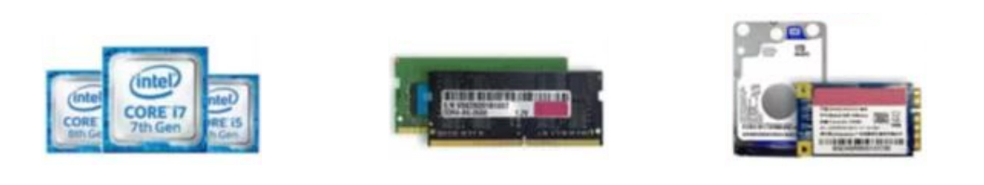

Intel I3/ I5/I7

2nd ~10th CPU

4GB/8GB/16GB

DDR3/DDR4

128GB/256GB/512GB/1TB SSD/HDD

1. **Detailed Pictures**

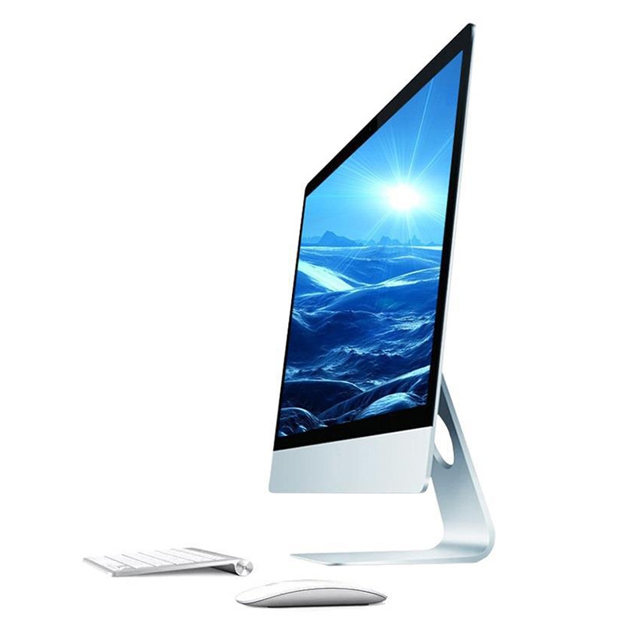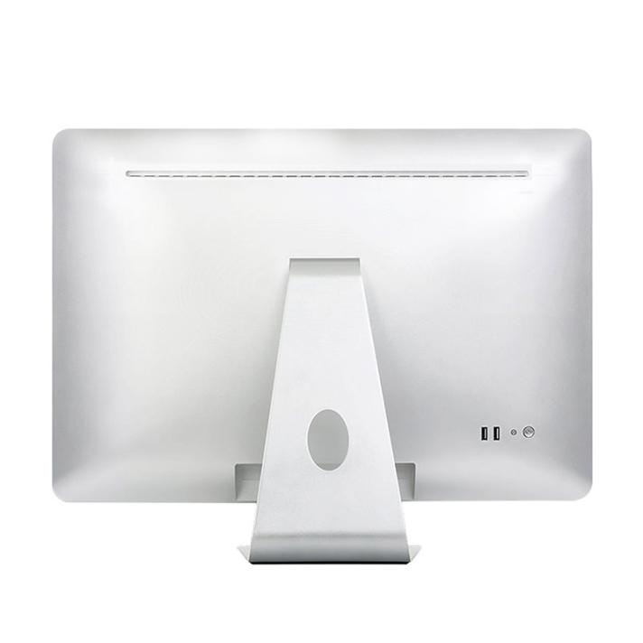

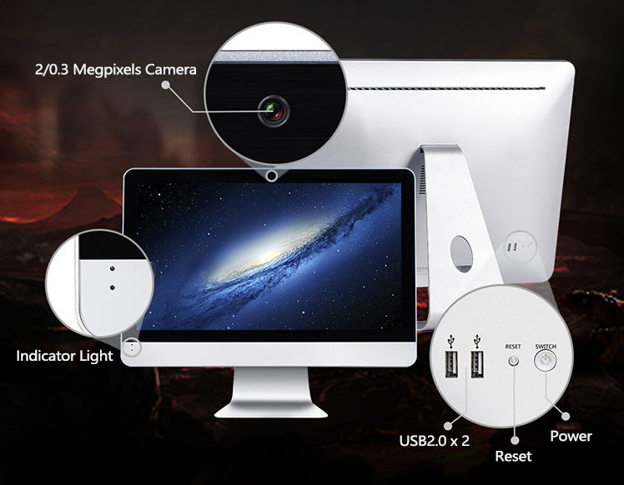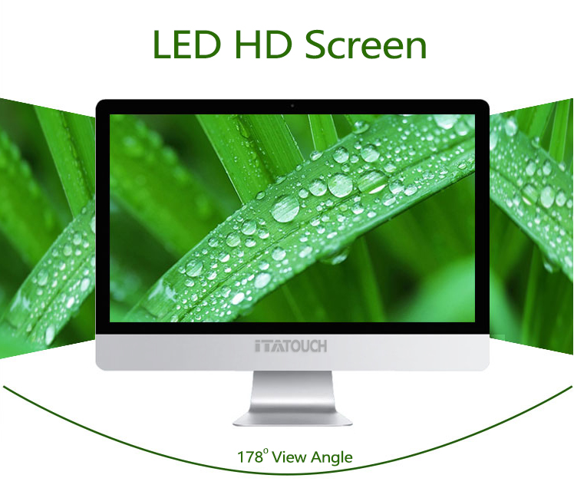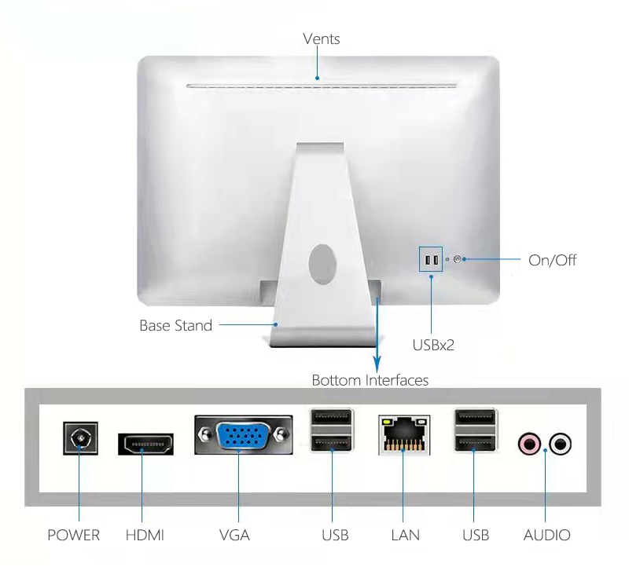

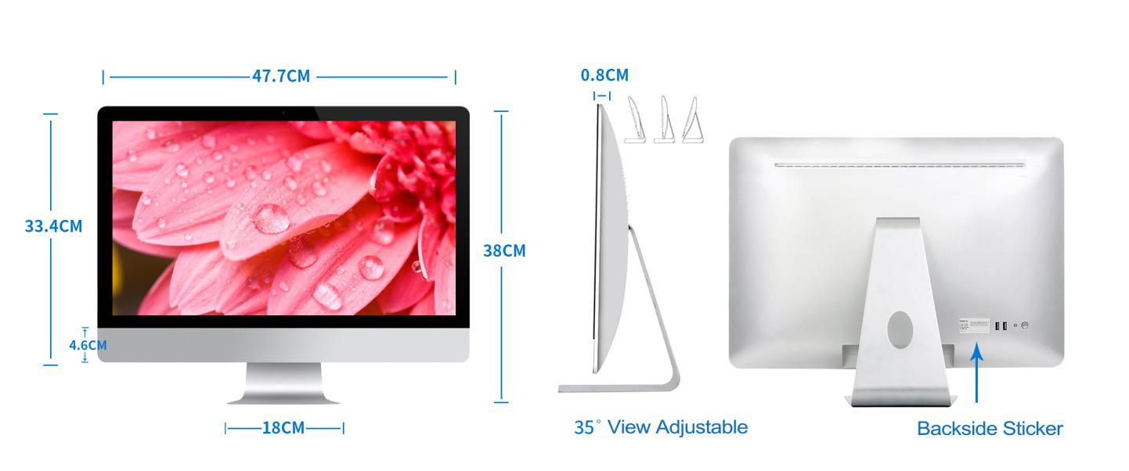

1. **Parameters**

|  |  |  |
| --- | --- | --- |
| Screen Panel | Size | 19 inch |
| Panel | LCD LED backlight |
| Ratio | 16:09 |
| Display area (HxV) | 410mm*250mm |
| Native resolution | 1440*900 |
| Pixel pitch (HxV) | 0.2835X0.2835mm |
| Brightness | 220cd/m2 |
| Contrast ratio | 1000:1 |
| Response time | 6ms |
| Viewing | 170°(H) /160° (V) |
| Colorful | 16.7M |
| Speaker & Camera | Speaker | Speaker Built-in speaker 8Ω 3W*2 |
| Audio | 5.1 channel output, 2 jacks, Mic Line in/out |
| Built-in Camera | 0.3M Pixel Color CMOS Sensor |
| Computer | Processor | Intel(R) Core(TM)i5 8th generation |
| Motherboard | Intel Chipset |
| Storage | SSD 256G |
| Memory | 8GB DDR4 |
| WIFI | WIFI 802.11b/g/n |
| LAN | 100/1000M Ethernet. RJ45 port |
| Interface | I/O | 1*Line out, 1*MIC in, 1*VGA Port, 2* USB2.0 Ports, 2* USB3.0 Ports, 1*LAN, 1*HDMI |
| Power | Power management | Compatible |
| Power Supply | 100V ~240V; 30Hz |
| Environment | Temperature | Working: -20℃~60℃, Storage:-40℃~85℃ |
| Humidity | Working: 10%~90%RH, Storage: 10%~95%RH |
| Max working time | 18 hours /day |
| Hardware & Accessories | Brezel Color | Sliver frame & shell |
| Shell | Aluminum frame, metal backside |
| Packing Accessories | Base stand, power cable, adapter |
| Product Dimension | 477*334*8mm (exclude stand) |
| Package Dimension | 538*445*195mm |
| Weight | N/T: 4.23kg; G/W: 6.5KG |
| Keyboard (option) | USB wire keyboard |
| Mouse (option) | USB wire mouse |
| Quality | Certification | CE, ROHS, ISO |

the above parameters are for reference only, please refer to the actual product

