用户手册
User Manual

工业空调系列
Industrial Air Conditioner Series

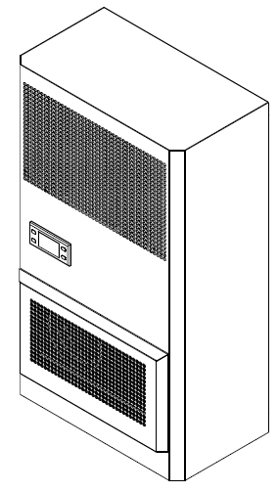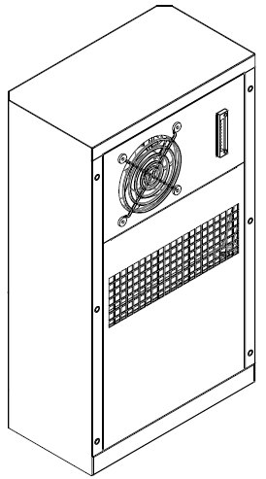

在产品安装使用前请仔细阅读本手册！
Reading this manual carefully before installation and using!

前言Foreword
本手册介绍了工业空调系列的使用须知、产品接线、操作指导、日常维护等信息。
本手册主要用来指导用户进行安装，维护本系列空调产品。
针对本系列产品的任何操作必须由专业的技术人员根据本手册的要求进行。

The manual describes industrial air conditioner series, wiring, operating instructions.
The manual is mainly used to guide users to install and maintain the series of air conditioners.
For the series of products of any operation must be made by the professional technicists according to the requirements of the manual.

变更记录Change History

版本//Version | 文件历史 // Change History | 日期 // Date
A | 创建 // Created | 2017-11-07

目录 contents

前言Foreword 2
变更记录Change History 3
声明Declaration 5
1. 简介Brief Introduction 7
1.1 产品描述 Product description 7
1.2 型号描述 Model description 8
1.3 符合标准 Conform to the standard 8
2. 包装与运输 Packing and Shipping 9
3. 安装 Installation 10
3.1 安装前准备 Before Installation 10
3.2 空调器安装 Air Conditioner Installation 10
3.3 电气布线 Electrical Wiring 11
3.4 冷凝水汽化装置 Condensed water vaporizing device 11
4. 运行逻辑 Operation Logic 13
4.1 开机运行 Running 13
4.2 控制逻辑 Control Logic 13
4.3 手操器使用说明 Instructions of Display Panel 15
4.4 告警与故障 Alarm and Fault 17
4.5 其他故障分析与处理Other fault analysis and processing 20
5. 产品维护Maintenance 21
6. 产品质保Warranty 22
7. 回收处理 Reclaim 23

声明Declaration

RoHS Compliance Declaration of
Cabinet AC air conditioner

European Guidelines 2011/65/EU (RoHS)
Legal regulation for Substances

Dear Sir/Madam,

Referring to the European guideline of 2011/65/EU, we confirmed that according to the current status of our knowledge and in accordance with the regulations, we could produce products complying with above mentioned guidelines especially for below type:

HRUC A 0＊＊ / H＊＊

Yours sincerely
Declaration of Conformity
Suzhou Quick Thermal Control Technology Co. Ltd
We here with declare the following products:
Product Name: T A 0＊＊ /H＊＊ series products
series products is in conformity with the following directives:
2006/ 42 / EC | Machine Directive | EN ISO 12100
2006 / 95 / EC | Low Voltage Directive | EN 60 335-1:2012
2004 / 108 / EC | EMC-Directive | EN 60 335-2-40
2009/ 105 / EC | Simple Pressure Vessels | EN 61000-6-1:2007
97/23/EEC | The Pressure Equipment Directive, article3  Paragraph 3. | EN 61000-6-4, Emission
 | The Pressure Equipment Directive,category1
 | The Pressure Equipment Directive,category2

and was manufactured in conformity with the following harmonised standard:
furthermore manufactured in conformity with the following disharmonised standard:
2011/65/EU | RoHS Directive
2002/96/EC | Waste of Electrical and Electronic Equipment (WEEE)

and furthermore declares that it is not allowed to put the machinery into service until the machinery into which it is to be incorporated or of which it is to be a component has been found and declared to be in conformity with the provisions of above-mentioned Directives and with national implementing legislation i.e. as a whole, including the machinery referred to this declaration.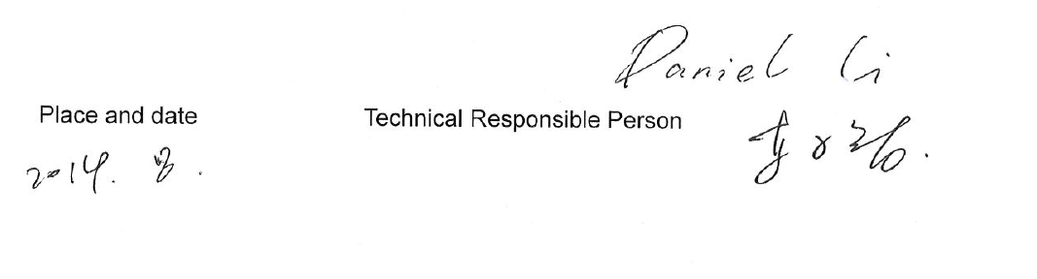

- 简介Brief Introduction

1.1 产品描述 Product description
本产品广泛应用于户内机床、电池柜、电气柜、工业控制柜等需要散热的场合。
电网适用范围：交流 230VAC±15% 50Hz/60Hz
其他电源制式请参考铭牌。
注意：在运输、储存以及使用过程中，必须严格按照包装上的指示保持空调竖直向上放置。

This product is widely used in the indoor machine, battery cabinet, industrial control cabinet need to be cooling occasions
Grid application scope: AC 230VAC±15% 50Hz/60Hz
Other power supply system, please refer to the nameplate.

Warning: In the process of transportation, storage and use must be in strict accordance with the instructions on the package to keep air conditioning placed vertically upward.

1.2 型号描述 Model description

举例// For example：
T A 0＊＊ / H＊＊
T: | 公司机柜用散热产品系列// Indoor enclosure cooling；
A: | 标准型空调// Standard air conditioner；
0＊＊: | 制冷量为＊＊×100W（L35/L35）// Cooling Capacity is ＊＊×100W（L35/L35）
A: | 空调电源：230VAC 50/60Hz//Power: 230VAC 50/60Hz；
H＊＊: | 制热量为＊＊×100W（L35/L35）// Heating Capacity is ＊＊×100W（L35/L35）。

1.3 符合标准 Conform to the standard
Standard | Description
GB/T 17626 | Electromagnetic compatibility(EMC)
GB4706.1 | Safety household and similar electrical appliance
GB4798.1 | Environmental conditions existing in the application of electric and electronic products - storage
GB4798.2 | Environmental conditions existing in the application of electric and electronic products - transport
GB4798.3 | Environmental conditions existing in the application of electric and electronic products - use
CE | The third party certification

- 包装与运输 Packing and Shipping
- 空调采用纸箱包装，附件等资料也放置于包装箱内。
Air conditioner packed in paper cases, the package includes Annex.
- 空调在运输时请注意以下事项：
The air conditioner during the transportation, please pay attention to the following matters:
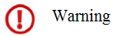
图2-1 包装箱标识
Figure2-1 Packing mark
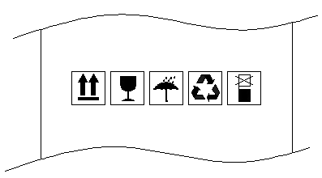
- 搬运或者运输过程中空调必须按朝上放置。严禁倒置、平放、过度倾斜及碰撞。
During Handling or transport, Air conditioner must be upward placed as. No inverted, flat, excessive tilt and collision.
- 空调为精密仪器，在搬运或者运输过程中，应小心轻放，包装箱上禁止踩踏，禁止站立或放置其他重物。
Air conditioner is precision instrument, in handling or transport process, should be handled with care, package boxes do not step, prohibit standing or placing other heavy objects.
- 搬运或运输过程中，注意防潮、防水、防雨。
During Handling or transporting, pay attention to moisture, water, rain.

- 安装 Installation
  - 安装前准备 Before Installation
安装前至少需准备以下工具：十字螺丝刀、一字螺丝刀、密封条、老虎钳。
You have to prepare the following tools before installation: cross screwdriver, slot type screwdriver, sealing strip, vice.

  - 空调器安装 Air Conditioner Installation
- 安装步骤：
- 在安装面上画出柜门开孔示意图，将阴影部分切割掉。不同型号空调的柜门开孔示意图请参考相应规格书；
- 根据下图示意，将空调器安装在机柜上；（此安装方式为螺柱安装，需选配双头螺柱）
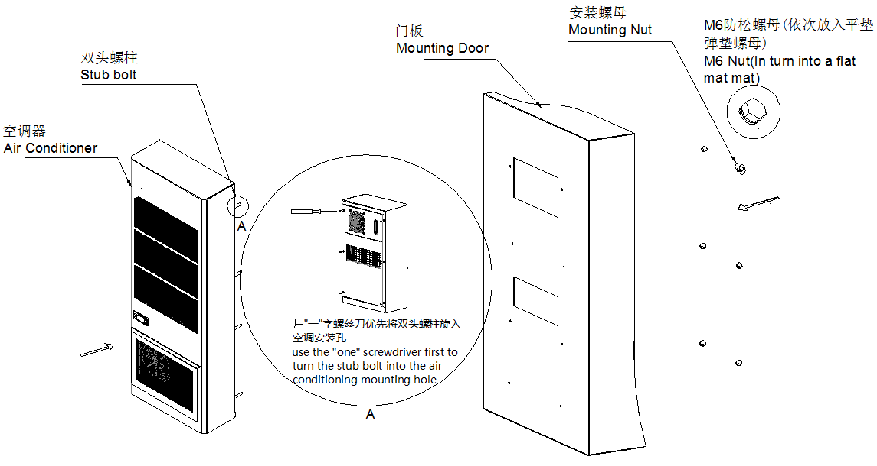
- 下图为机器安装后效果图及机柜内部安装后双头螺柱伸出的长度，请作参考；
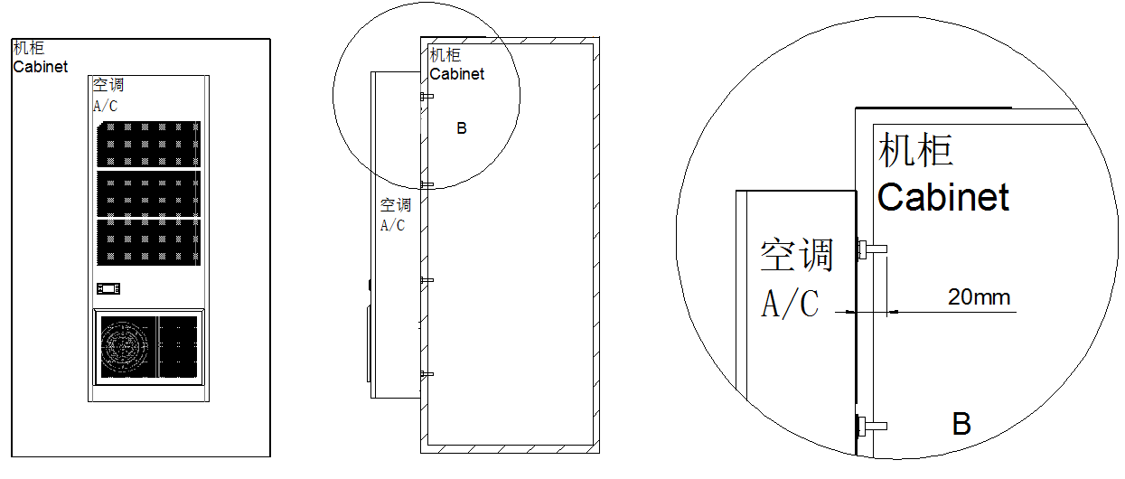
- Installation steps:
1. Draw on the cabinet mounting cut-out map according to Figure, cut off the shadow part. Different models of air conditioner cabinet mounting cut-out maps refer to its specification.
2. According to the direction of the schematic of installation, installed the air conditioner on the cabinet.（This installation is installed in the stud mounting. It needs stub bolt）
3. The following picture shows the length of the post after the installation of the machine and after the installation of the cabinet. Please refer to it.

- 安装完成后的确认检验项：
- 请勿在高油污、易燃气体、高腐蚀性及环境温度超过55℃、湿度超过95%的环境下使用该产品；
- 确保产品安装后倾斜度不大于3°；
- 确保控制柜密封良好以免漏入空气产生不必要的冷量损失和产生过多的冷凝水；
- 产品安装结束后，确保产品直立30分钟后再加电运行。

- Double check lists after Installation:
1. Don’t apply this unit in high oil, burning gas, explosive gas, strong corrosively condition, the ambient air must be under 55℃, and the humidity not higher than 95%;
2. Make sure that the lean of the product no more than 3°;
3. Make sure that the cabinet should be sealed well to avoid the cooling losing and avoid ambient moisture penetrate into cabinet, this will avoid produce more condensate water;
4. Ensure that the product is up and running in upright 30 minutes.

  - 电气布线 Electrical Wiring

空调器在使用前需根据本手册的说明进行电气连接，建议客户优先使用附件中的线缆。客户可以自备线缆，如果客户不能确定所选电缆规格是否合适，可联系售后服务部门。

Does Electrical Wiring according to the manual before use the air conditioner; we suggested preferring to use cables in the attachments. You should call the After-sale Service Department, if you cannot sure the cable specification be made by your-self.
图3-1 电源端子示意图
Figure 3-1 Schematic of power terminal
表3-1 接线端子说明 Table 3-1 Terminal instructions

3.4冷凝水汽化装置（可选）

Condensed water vaporizing device（optional）
该系列空调可选配内置冷凝水汽化装置，本装置将空调产生冷凝水直接蒸发变成水蒸气排放到大气中，有效的解决车间厂房等一些场所不适合接管排放冷凝水的场景。特别注意此装置并不能保证所有的环境下无冷凝水，在湿度超过50%时，也会有冷凝水从排水管中滴出。
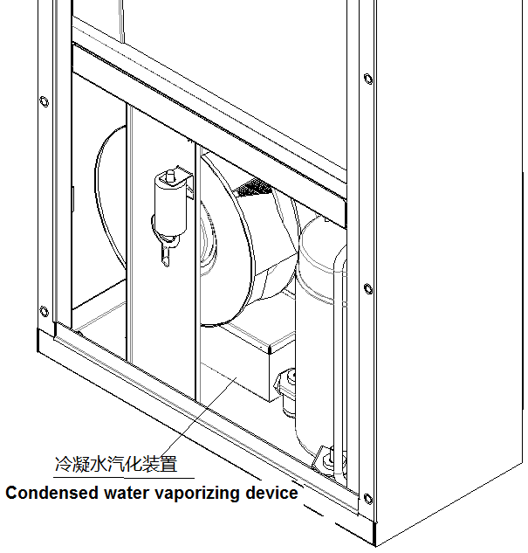
This series of optional built-in air conditioning condensate vaporizing device, this device will have a direct evaporation condensation water into air conditioning, water vapor emissions into the atmosphere, effectively solve workshop and other places are not suitable for to take over the discharge of condensed water scene. Special attention to this device does not guarantee that there is no condensation in all the environment, and when humidity exceeds 50%, there will also be condensed water dripping from the drainpipe.

- 运行逻辑 Operation Logic

4.1 开机运行 Running
接线完成并确认接线正确后，此时可接通交流电源使空调首次上电运行。
空调上电后，首先执行自检程序，依次对内风机、温度传感器、加热器、外风机、压缩机进行检验。
自检过程中若发现故障则显示相应故障告警并进入告警状态。
Completed and confirmed the wiring correct, then you can connect to the AC power to air conditioner for the first time to run on electricity.
After power on air conditioner, first of all it will be self-checking: internal fan, temperature sensor, heater, external fan, and compressor.
空调上电运行过程中，若发生异常噪音、震动，请立即切断电源，并通知专业人士进行检查。
When the air conditioner is running, if there is abnormal noise, vibration, please cut off power immediately and notify the professionals to inspect.

4.2 控制逻辑 Control Logic
运行模式：待机模式、制冷模式、加热模式 、告警模式。
Operational mode: standby, cooling, heating, and alarming.
- 待机模式
若回风温度＜压缩机启动设置温度（默认35℃），则空调处于待机模式，此时只运行内风机，显示器显示当前回风温度。
- Standby mode
If the return air temperature is lower than the default set point of Compressor start temperature (35℃), the air conditioner is in a standby mode. At this time, the internal fan is running only, the monitor displays the current return air temperature.
- 制冷模式
若回风温度≥压缩机启动设置温度（默认35℃），则空调进入制冷模式。外风机先运行，显示器上标志亮。外风机运行60秒后，压缩机启动，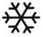标志亮。压缩机一旦启动，最小运行时间不小于设定值（默认为5分钟）。
若回风温度≤压缩机启动设置温度（默认35℃）—压缩机运行回差值（默认5℃），且压缩机持续运行时间≥最小运行时间（默认5分钟），则系统停止制冷。此时压缩机先关闭，熄灭。外风机滞后一段时间再关闭，熄灭。
- Cooling mode
If the return air temperature is greater than or equal to the default set point of compressor start temperature (35℃), the air conditioner enters the cooling mode. The external fan is running, the monitor displaysymbol. The compressor is running after external fan 60 seconds, the symbol is bright. If the compressor is running, the minimum running time is less than the set time (default time is 5 minutes).
If the return air temperature is less than or equal to the default set point of compressor start temperature (35℃) subtracts compressor stop hysteresis temperature (5℃), and the compressor running time is more than or equal to the minimum set time(the default time is 5 minutes),then the compressor stopped. The symbol is extinguished. The external fan stopped after a while, and the symbol extinguished.
- 加热模式
若回风温度≤加热器设置温度（默认0℃）-加热器运行回差温度（默认5℃），则加热器开启，对系统进行加热，此时亮。
若回风温度≥加热器设置温度（默认0℃）+加热器运行回差温度（默认5℃），则加热停止，熄灭。
注：加热功能只适用于带加热器机型。
- Heating mode
If return air temperature is less than or equal to heater start temperature (0℃) subtracts heater stop hysteresis temperature (5℃), the heater runs to heat the system and the symbol bright.
If the return air temperature is greater than or equal to heater start temperature (0℃) plus heater stop hysteresis temperature (5℃), the heater is stopped and the symbol extinguished.
Attention: The heating function is only applicable to models with heater.

4.3 手操器使用说明 Instructions of Display Panel
在正常情况下，手操器显示柜内温度，告警时显示告警代码；
手操器底部为状态栏，不同的指示灯代表不同状态；
通过手操器可查看空调器各项参数及对各参数进行设置（用户参数）。
The display panel shows cabinet temperature under normal circumstance, and shows alarm code when there is a malfunction.
In the bottom is the status bar, different lamp represents different status.
You can check and set various parameters of air conditioner by the display panel (User Parameters).

图4-1 手操器示意图
Figure 4-1 the display panel diagram
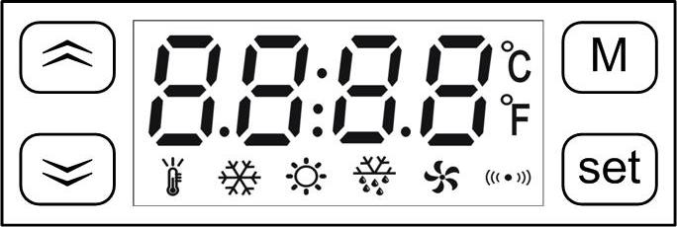

表4-1 手操器指示灯含义
Table 4-1 the meanings of lamps on the display panel
指示灯// lamps | 描述 // Description
 | 闪烁表示空调处于自检或温度设置状态  Flashing when self diagnose or temperature setting mode
 | 闪烁表示空调即将进行制冷，常亮表示空调正在进行制冷  Lamp on when cooling
常亮表示空调正在进行制热
Lamp on when heating
 | 常亮表示外风机正在运行  Lamp on when external fan is running
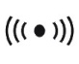 | 闪烁表示有告警发生  Flashing when alarm

- 蒸发盘管温度查询：
在主显示界面，按一次“”键，将显示蒸发盘管温度，再按一次“”键或按一次 “M”键返回到显示回风温度的主界面。
- 冷凝盘管温度查询：
在主显示界面，按一次“”键，将显示冷凝盘管温度，再按一次“”键或按一次 “M”键返回到显示回风温度的主界面。
注：空调出厂时已经进行过参数设置，默认参数请参考表5-2；部分参数需要密码才能设置，请联系客服。
- The evaporator temperature query:
Under the return air temperature interface, press“”once will show evaporator temperature, press again or press”M”, the monitor will return the main interface.
- The Condenser temperature query:
Under the return air temperature interface, press“”once will show condenser temperature, press again or press”M”, the monitor will return the main interface.
Attention: Air conditioner has been setting parameters, the default parameters refer to table 5-2；
Part of the parameters need to password, please contact our customer service.
- 参数设置：
长按“M”键5秒，进入参数设置状态，显示参数代码，用“”键选择参数代码，选择一个代码后按“Set”键则显示该代码对应的参数值，这时再用“”键即可对参数值进行设置，设置完成后再按“Set”键，回到显示参数代码状态。在显示参数时按“M”键可退出参数设置状态，在设置参数值的过程中按“M”键表示放弃，退出但不改变参数值。
- Parameter setting:
Long press "M" key for 5 seconds, enter the parameter setting mode, then display the code of parameters, with "" key to select the code of parameters, select a code and press "Set" button will display corresponding parameter values of the code, then re-use "" button can set the parameters, after finished the setting, press "Set "button, back to display states. During the setting mode, Press "M" key to exit the parameter setting mode, in the process of the parameter values setting by pressing "M" button that give up, quit, but does not change the parameter value.
表4-2 设置代码
Table 4-2 Setting Code
代码  Code | 参数名称  Parameter name | 默认值  Default Value | 范围  Range | 备注  Remarks
F01 | 压缩机启动温度  Compressor start temperature | 35 | 20～50℃
F02 | 压缩机停止回差温度  Compressor stop hysteresis temperature | 5 | 2～8℃
F03 | 加热器启动温度  Heater start temperature | 0 | -15～15℃ | 该功能仅适用于含加热器机型。  This function is only applicable to the models with heater.
F04 | 加热器停止回差温度  Heater stop hysteresis temperature | 5 | 1～15℃
F05 | 高温告警温度  High temperature alarm | 55 | 35～70℃
F06 | 低温告警温度  Low temperature alarm | -40 | -42～15℃
F07 | 通信地址  Communication address | 1 | 1～255

4.4 告警与故障 Alarm and Fault
显示器正常时显示回风温度值，告警时交替显示回风温度和告警代码，告警代码定义如下表：
The monitor displays return air temperature at normal, If the alarms, temperature and alarm codes are displayed alternately, the alarm code as follows:
表4-3 故障代码
Table 4-3 Alarm Code
代码  Code | 故障名称  Code Name | 故障机制  Principle | 故障处理方法  Process Method
E01 | 回风温度传感器故障 Return air temperature sensor fault | 回风温度传感器短路或断路  Return air temperature sensor is short circuit or open circuit | 1、用万用表检查回风温度传感器是否有断路或者短路现象。  Use the multimeter to check whether the return air temperature sensor is short circuit or open circuit.  2、回风温度传感器脱落。  Check whether the return air temperature sensor is loosening.
E02 | 蒸发温度传感器告警 Evaporator temperature sensor alarm | 蒸发温度传感器短路或断路  Evaporator temperature sensor is short circuit or open circuit | 检查蒸发温度传感器是否有断路或者短路现象。  Check whether the evaporator temperature sensor is short circuit or open circuit.
E03 | 冷凝温度传感器告警 Condenser temperature sensor alarm | 冷凝温度传感器短路或断路  Condenser temperature sensor is short circuit or open circuit | 检查冷凝温度传感器是否有断路或者短路现象。  Check whether the condenser temperature sensor is short circuit or open circuit.
E04 | 内风机告警  Internal fan alarm | 1、内风机不能正常工作  The internal fan is not working properly.  2、蒸发器盘管温度一直连续15分钟低于0度  The evaporator temperature has been below zero in 15 minutes. | 1、检查内风机线和内风机的连接是否脱落或松动。  Check Whether the internal fan line is loosening.  2、检查系统是否泄漏。  Check whether the system leakage.
E05 | 外风机告警  External fan alarm | 1、外风机不能正常工作  The external fan is not working properly  2、冷凝器盘管温度一直连续3分钟高于77度  The condenser temperature has been above 77 degrees in 3 minutes. | 1、检查外风机线和外风机的连接是否脱落或松动。  Check Whether the external fan line is loosening.  2、检查系统是否泄漏。  Check whether the system leakage.
E06 | 制冷剂泄漏告警  Refrigerant leakage alarm | 1、系统内制冷剂不足  Lack of refrigerant  2、蒸发盘管温度传感器松脱  The evaporator temperature sensor is loosening | 1、检查系统是否泄漏。  Check whether the system leakage.  2、检查蒸发盘管温度传感器是否松脱。  Check whether the evaporator temperature sensor is loosening..
E07 | 低温告警  Low temperature alarm | 机柜内温度低于设定值  The cabinet temperature is higher than the set point | 加热器开启，直到告警消除。  The heater is running until the alarm elimination.
E08 | 高温告警  High temperature alarm | 机柜内温度高于设定值  The cabinet temperature is higher than the set point. | 打开机柜门散热，直到告警消除。  Open the cabinet door until the alarm stop.

4.5 其他故障分析与处理Other fault analysis and processing
故障状态  Fault state | 原因分析  Analysis of the reasons | 故障排除方法  Solutions
电源接通后，柜内温度过高，但空调不运转。  Power on the switch, the cabinet temperature is too high but the air conditioner is not working. | 1、停电或无电源。  Power failure or no power.  2、设定温度高于柜内温度。  The cooling set temperature is higher than the cabinet temperature.  3、系统故障。  System fault. | 1、检查电源、电路。  Check the power supply and the electric circuit.  2、根据需要设定压缩机启动温度。  Setting cooling temperature according to the needs.  3、请与专业维修人员联系。  Please contact professional maintenance.
设备正常运转，但制冷效果不理想  The air conditioner is running but the cooling effect is not good. | 1、该机型制冷能力与负荷不匹配。  The cooling capacity of the air conditioner is not match with the load.  2、环境温度过高。  The ambience temperature is too high.  3、其他系统故障。  Other system fault. | - 根据负荷大小重新选配或增配制冷设备。  To add or choose another air conditioner according to the load.  - 请确保机器工作环境温度在正常使用范围内。  Ensure the machine is used in the correct range.  - 请与专业维修人员联系。  Please contact professional maintenance.
正常运转中。突然停止制冷，且电器系统无故障。  The machine is stopping suddenly, and the electric system is normal. | - 柜内温度已达到设定温度。  The cabinet temperature greater than or equal to the cooling set temperature.  - 其他系统故障。  Other system fault. | - 根据需要设定压缩机启动温度。  Setting cooling temperature according to the needs.  - 请与专业维修人员联系。  Please contact professional maintenance.

- 产品维护Maintenance
- 准备工具Prepare tools
表5-1 维护工具 (Table 5 -1 Malignance Tools)
序号//No. | 工具Tools
1 | 万用表//Multimeter
2 | 十字螺丝刀//Phillips screwdriver
3 | 一字螺丝刀//Slotted screwdriver

- 日常维护Routine maintenance
表5-2 日常维护(Table 5 -2 Routine maintenance)
序号  No. | 检测项目  Check items | 检验方法  Check methods | 故障解决方法  Solution
1 | 电源线牢固性  Power line firm | 1、关闭空调输入电源。  Turn off the supply power  2、用手拉动电源线，观察是否有松脱现象。  Pulled the power line，watch whether the line is loosening  3、用螺丝刀拧动电源线端子上的螺丝，观察是否有松动现象。Screw the screws on the power cord terminals with a screwdriver, watch whether the screw is loosening | 若发现有电源线有松脱或者松动现象，应重新用扎带绑紧电源线；用螺丝刀将松动的螺丝拧紧。If there is a power line to loose or loosening, You should be used to tie tight power line; use a screwdriver to loose screw.
2 | 电压稳定性  Voltage Stability | 用万用表测量空调输入电压，观察用电压是否在正常范围内  Use the multimeter to measure air conditioner input voltage to watch whether the voltage is within normal range. | 若电压不在正常供电范围，请立刻关闭输入电源。直到输入电源稳定后才可再次运行空调。If the voltage is not within the normal range, Please turn off the power supply immediately. Power on the air conditioner until the supply voltage within normal range.
3 | 安装螺丝牢固性  Screw firmly | 用螺丝刀拧动空调的安装螺丝，观察是否有松动现象。Use screwdriver to screw the screws and watch whether the screw is loosening | 若有松动现象，则拧紧螺丝  If the screw is loosening, please tighten it.
- 产品质保Warranty
- 保修期Warranty Period
产品质保12个月（从产品开始运行时起），或最大18个月（从产品发货日时起），与公司另有协议的以协议为准。
The product guarantee period is 12 months from product up-running time or Max. 18 month from product delivery date, or depends on agreement with the company.
- 质保范围 Warranty Coverage
本产品在保修期内，凡属于产品本身质量问题而导致故障的，本公司将为您免费维修，客户报修时需提供产品标号。但是由以下任何原因造成的故障不属于我司的保修范围。
      - 已超过保修期的；
      - 不能提供产品出厂编号的（见机身贴示的铭牌）；
      - 由于在异常条件或环境中运行，或者用非本使用说明书中指定的不恰当安装方式安装、维护或操作导致的故障；
      - 非本设备造成的故障，比如由用户的设备、用户的软件等造成的故障；
      - 用户自行更换或拆装产品零部件造成损坏的，或由非授权维修服务者拆修而造成损坏的；
      - 诸如火灾、地震、洪水等不可抗拒力而造成损坏的故障。
During the warranty period, all belong to the product itself quality problems caused by fault, the company will be free for you to repair; Household repair is required to provide the product label. But by any of the following causes the failure does not belong to our warranty.
- Out of the Warranty period
- Cannot provide the product label(the product label is on the nameplate);
- Because of the abnormal condition or environment ,or the instructions specified in the inappropriate installation, maintenance or operation causes the fault;
- Not caused by equipment failure, caused by user’s other equipment or software.
- User changed or disassembles by their-selves, or maintained by the person without authorization.
- Caused by force majored such as fires, earthquakes, floods and other damage to the fault.
- 免责声明 Disclaim

我司的保修仅限于已发送的产品。我司对可能由设备故障衍生的任何损失不负责任。

The warranty is for the delivered products.
Irresponsible is for any loss that may be caused by equipment failure.

- 回收处理 Reclaim

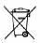

到本产品使用期限或不再使用该产品时，请勿将本产品直接作为垃圾处理，请交给当地政府认可的废物收集中心进行处理。

At the end of the unit working life, the produce must not be disposed of as urban waste; it must be taken to a special local authority differentiated waste collection centre or to a dealer providing this service.

Suzhou Qucik Thermal Control Technology Co.Ltd
苏州酷克温控科技有限公司
No.15 xiangpu Rd Suzhou Industrial Park Suzhou China
中国·苏州·工业园区·翔浦路15号
Tel: +86 512 65335116

