DORLAND Intrinsically Safe Noise Cancelling Bluetooth Ex_headset02
Developed by Beijing Dorland System Control Technology Co. Ltd., the Safe Noise Cancelling Bluetooth Ex_headset02 adopts advanced technology with intrinsically safe circuit. This headset adopts the new generation of Bluetooth 5.0 high version, supports 24bit/192KHz lossless audio transmission, compared with Bluetooth 4.2, the transmission speed is faster and more stable, the signal is stronger, the ultra-low delay sound and picture synchronization, active noise reduction and passive drop Noise combination, turn on noise reduction, as if you are in a quiet time, let you focus on enjoying the music feast.

In addition, this headset has built-in microphone talk, can answer hands-free phone, peripheral 3.5mm audio cable port, can be switched to wired mode at any time, which can reduce the headphone power consumption and can listen to it. The earmuffs are skin-friendly and high-quality simulation. Protein skin, ergonomic head beam, comfortable to wear, no pressure, healthy and breathable, rebound and no deformation. Explosion-proof certificate is Ex ib IIC T4 Gb Zone1 / Div.1. The model is especially suitably used in dangerous environment such as petroleum, chemical, pharmaceutical, oil depot, oil & gas, tank farm as well as the dangerous sites with combustible and explosive gas. It is convenient for users’ timely production dispatching and online communication.

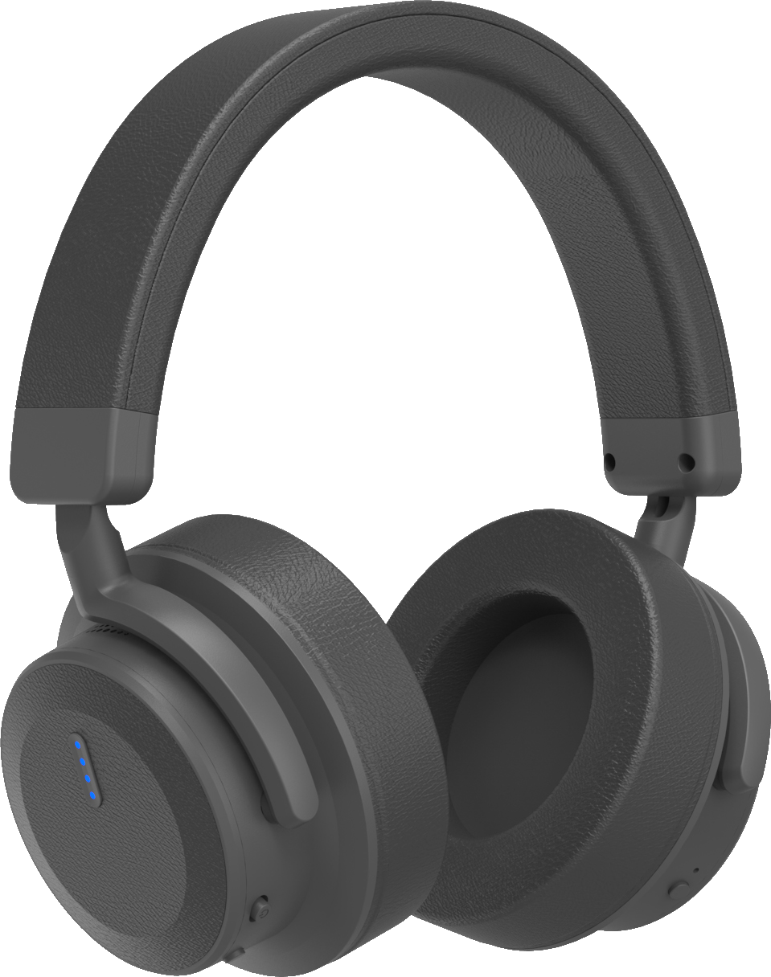
Ex-mark: Ex ib IIC T4 Gb
Certification No.: CCRI 19.2278

Bluetooth：5.0
Transmission distance: 10m
Bluetooth chip: CSR8670
Supporting agreement: aptX LL，aptX，AAC，SBC
Noise reduction performance: 98%
Speaker: 40mm
Battery capacity: 3.7V 320mAh lithium battery
Ex Battery: Lithium ion polymer battery
Charging time: 3h
Charging interface: Type C
Working hours: noise reduction only: 30h
Bluetooth only: 25h
Bluetooth + noise reduction: 15h
Headphone jack: 3.5mm
Size: 21.5*20.2*4.6cm
Weight: 282g
Wearing method: headset (adjustable head beam, adapt to different people's head size)

