

**User’s Manual**

***Model DS400***

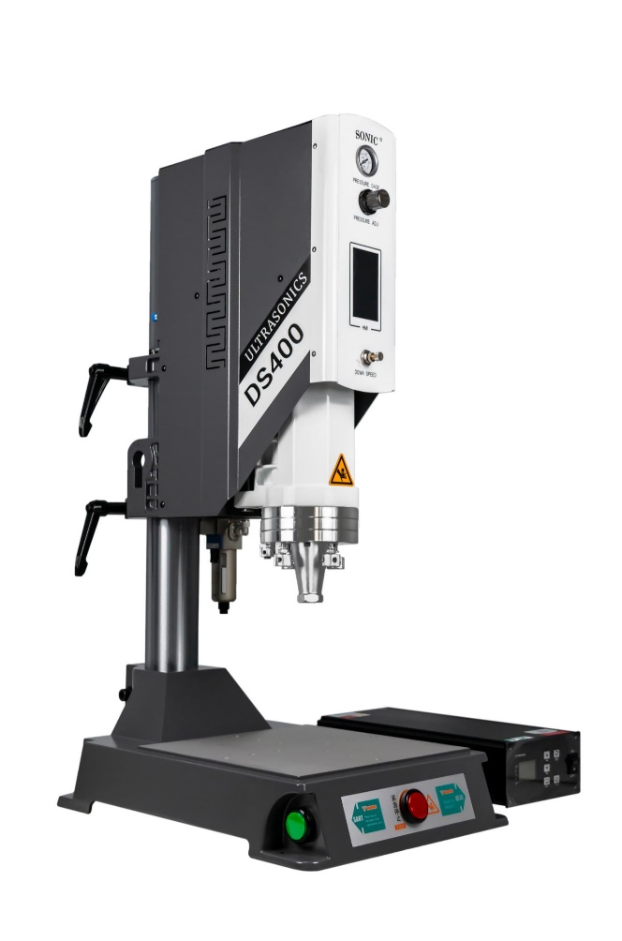

**Contents：**

1. Preface 2

2. Precautions: 2

3. Installation Place 3

4. Power Supply 3

5. Ultrasonic Welding Principle 3

6. Pictures Of Machine 5

7. Power supply/connection ports 7

8. Port Connections 12

8.1 Control Input port 12

8.2 Working Status Output Port 13

8.3 Analog Quantity Input/Output Port 14

8.4 Communication Port 14

8.5 Communications Ports for Human-Machine Interface 16

9. MODBUS PROTOCOL 17

10. Power Supply

11. Operation Panel 17

11.1 Password Keyboard, Parameter Keyboard 17

11.2 Version Information Page 18

11.3 Main Page 19

11.3.1. Welding record page 19

10.3.2 Trigger preparation page 20

11.3.3 Parameter Setting Page 21

11.3.4 QA Management Page 23

11.3.5 Protection Function Page 23

11.3.6 Factory Setting 24

11.3.7 Amplitude calibration 25

12. Trouble Shooting 26

13. Quality Guarantee 29

14. Additional Information 30

15. Contact us 30

# Preface

Dear users,

Thank you for using KnMTech ultrasonic systems, a smart, digital control ultrasonic power supply developed by our company.

Before using this product, please read this manual carefully and be familiar with the operation regulations and parameter scopes.

**Only Professional technicians or trained personnel can commission or maintain this product.**

# Precautions:

Please read this manual in details before operation to guarantee a smooth operation and self-safety.

Only professional personnel is allowed to install this system. Operators must be trained before work.

Protection measures have to be taken for operation in hazardous environment. As some energy will be transformed into heat during the operation, be cautious that the accumulation of heat will lead to explosion or burning without any protection.

Peripheral electric device electromagnetic compatibility must meet the requirement of the related country. All the operation parameters can be set by user, but the parameters protected by passwords shall be kept at factory default parameters. For any support, please contact our technical personnel. It is strictly prohibited to turn on the machine with a loose welding horn.

When moving or maintaining the device, it has to be handled by professional personnel under condition when power is off.

For repairing or maintaining the generators dust has to be removed by compressed air blower or brush. Please don’t use cleansing reagent to clean the case or LCM interface. Cloth with slight water can be used for rubbing the dirt.

High-load driving cables can control or signal monitoring cables shall be screened stranded conductors. Please don’t install it close to high-current devices. The screened cables shall be connected to power supply grounded line. All the driving cables can control cables shall be grounded, and the generator’s ground line shall be connected to the ground line of power supply.

Pay more attention to the malfunction codes on the generator to facilitate early action to prevent expansion of the malfunction.

The generator shall be installed in correct direction to assure firmness without loosening. Power supply specs must meet the demand of the generator.

Professional personnel shall be in charge of the repair or maintenance if any of following happens:

After turning off the power:

When any liquid or metal or conductive material goes into the generator;

When cable connection is loose or damaged;

When the power supply is installed loose;

When the displayed contents is obviously different from normal conditions.

Attention: Please do the maintenance with prior agreement of chief technician.

# Installation Place

The generator will produce heat during work, over-heat will lead to over-heat protection (see details in “Over-heat malfunction”, so we used strong cooling system.

The distance between generator vent port and other obstacles shall be kept in 10cm. The temperature shall not exceed 40℃ and moisture shall be exceed 75%.

# Power Supply

Input: AC 220V, 50/60Hz.

Grounded 3-core cables shall be used to connect with generator.

**Power supply fuse is inside the generator. When it is needed to replace the fuse, the generator case has to be opened.**

# Ultrasonic Welding Principle

The ultrasonic generator converts 50/60hz electric current into 15khz,20khz, 30khz or 40khz or higher frequency energy, and output to the piezoelectric ceramics inside the converter, to make same frequency vibrations by the converter, and the mechanical movement will be transmitted to the booster that can change the vibration amplitude, and to the welding horn. The horn will transmit the received vibration energy to the bonding surface of two parts.

In this bonding area, the vibration energy is converted into heat energy by way of friction, then plastic parts melts and joined with a certain pressure.

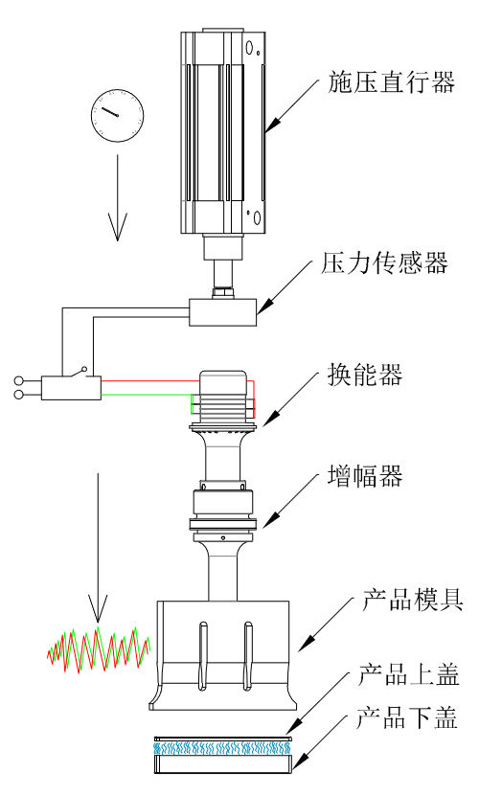

Welding horn

Converter

Pressure Sensor

Actuator

Booster

Product Lower Part

Product Upper Part

# Pictures Of Machine

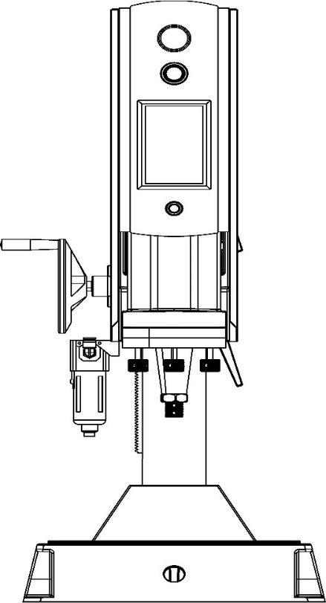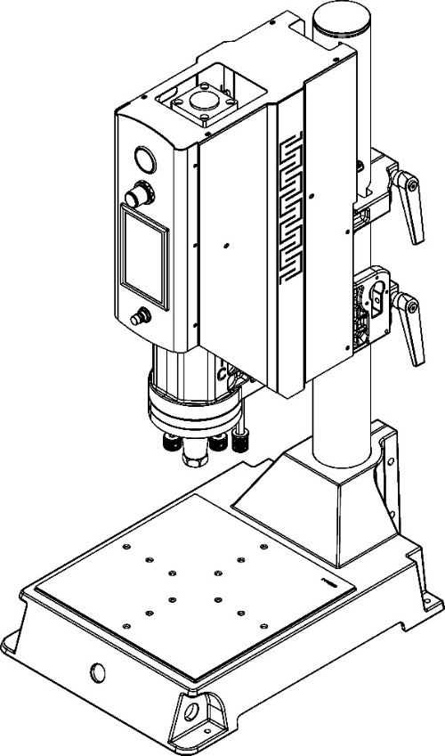

Pressure gauge

Machine Column

Pressure adjuster

Fixation handle A

Human-machine interface

Fixation handle B

v

One-way throttle valve

Converter installation flange

Working table

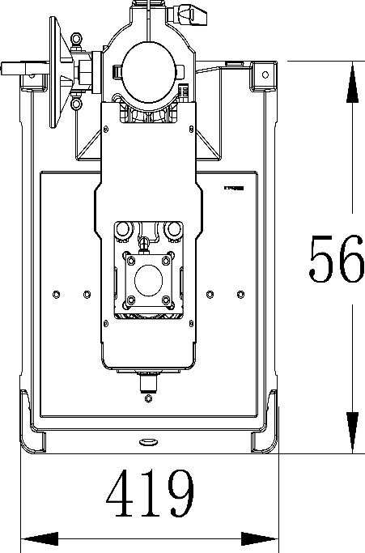

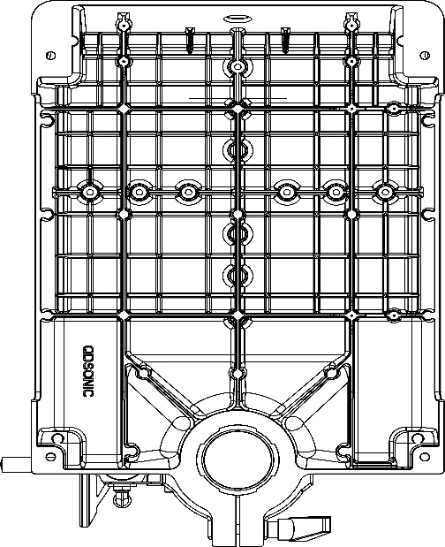

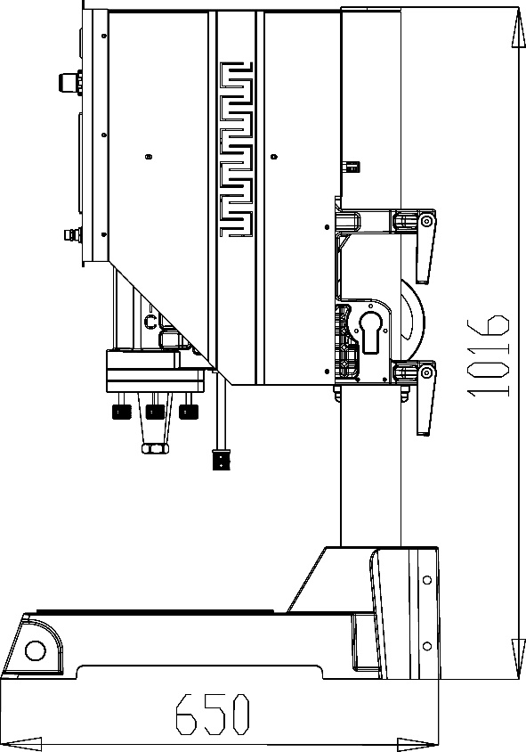

Leveling screw

Limitation screw

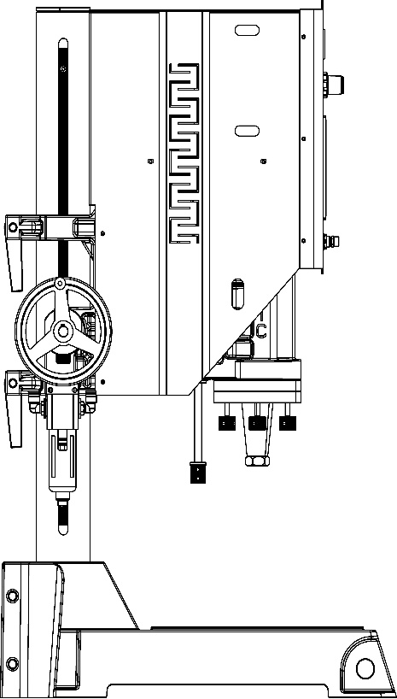

Filter cup

Signal plug

# Power supply/connection ports

**7.1 Power supply**

Power supply: AC 220V 50/60HZ

Grounded 3-core cables shall be used to connect with generator.

**Power supply fuse is inside the generator. When it is needed to replace the fuse, the generator case has to be opened.**

**Note:** The input power must be disconnected before replacing the fuse. Please replace the damaged fuse with one of the same specifications. For details, please refer to "Power Specification Table" (page P8).

**7.2 Power connection port/external control input/output interface**

 **B**

**C3**

**A** **C2 C1**

**7.2.1 Power supply input interface (A)**

**A:** L 220VAC power live wire

**B:** N 220VAC power null wire

**C:** PE Power supply grounded line

**Note:** Grounded 3-core cables shall be used to connect with generator with the diameter no less than 1.5mm2

**7.2.2 High frequency output interface (B)**

**A:** HF+: connect to transducer “+” port

**B:** RF-: connect to transducer “-” port

**Note:** Please use shielded wire to connect, withstand voltage≥2000V

**7.3 Input/Output control interface (C1, C2, C3)**

**7.3.1 C1 port**

**1:** COM_24V: 24V power output common port **7:** AUX_3: Auxiliary port 3 input

**2:** READY: Ready to output **8:** AUX_2: Auxiliary port 2 input

**3:** Mvt: Cooling or Cylinder movement output **9:** AUX_1: Auxiliary port 1 input

**4:** H.F: Ultrasound output  **10:** START**:** Work start input

**5:** OVL: Operation overload output **11:** COM_0V: 0V power input common port

**6:** Error: Malfunction alarm output

**7.3.2 C2 port**

**1:** A_0-10V: External analog amplitude input **4:** GND: Internal power grounding

**2:** P_0-10V: Real-time Power output **5:** RS485_A: RS485 communication port A

**3:** FREQ: Frequency pulse output **6:** RS485_B: RS485 communication port B

**7.3.3 C3 port**

**1 2:** EXT_24V: 24V power supply

**3 4:** EXT_0V: 0V power supply

**Note**: If the input/output common port is not enough, it can be connected to Port C3. The 24V power supply of Port C3 and the public power supply of port C1 are connected internally.

**7.3.4 Input/output control interface (DB25)**

**COM_24V**

**COM_24V**

**COM_24V**

**COM_24V**

**COM_0V**

**COM_0V**

**COM_0V**

**COM_0V**

**COM_0V**

**RS485_B**

**RS485_A**

**GND**



**1 2 3 4 5 6 7 8 9 10 11 12 13**

**14 15 16 17 18 19 20 21 22 23 24 25**

**ERROR**

**OVL**

**H.F**

**READY**

**Mvt**

**AUX_3**

**AUX_2**

**AUX_1**

**START**

**A_10V**

**P_10V**

**FREQ**

**GND**

## 7.4 Power Supply Connection Ports/Outer Control Input/Output Ports

|  |  |  |  |
| --- | --- | --- | --- |
| Pin | Name | Status | Function description |
| C1_10 | Start | Input ports | US start up (Note 1) |
| C1_9 | AUX_1 | In Standard mode: US searching; in Auto mode, US trigger (Note2) |
| C1_8 | AUX_2 | In Standard mode: amplitude segmentation; in Auto mode: Emergency stop (Note3) |
| C1-7 | AUX_3 | In Standard mode: Shake-off control; in Auto mode: grounding detection (Note4) |
| C1_11 | COM_OV | Common port for output |
|  | | | |
| C1_2 | READY | Output ports | “READY” status output. |
| C1_3 | Mvt | “Hold” status output (Note5) |
| C1_4 | H.F | “US work” status output (Note6) |
| C1_5 | OVL | “Overload” status output (press RESET or US search to remove it. |
| C1_6 | ERROR | “Error” status output (Note7) |
| C1_1 | COM_24V | Common port of output ports |
|  | | | |
| C3_1, C3_2 | 24V | External control power supply | 24V output positive pole (24V/1A) (Note 8) |
| C3_3, C3_4 | 0V | 24V output negative pole (Note8) |
|  | | | |
| C2_1 | A0_10V | Amplitude control | Amplitude control input 0-10V (10-100%) |
| C2_2 | P0_10V | Power output | Power output 0-10V(10-100% rated) |
| C2_3 | FREQ | Frequency output | Frequency pulse output (3.3V/10mA) |
| C2_5 | RS485_A | Communication ports | RS485 (MODBUS_RTU)communication ports |
| C2_6 | RS485_B |
| C2_4 | GND | Internal power grounding | Internal power common grounding (C2 port common grounding) |

**Note 1:** Select “Key ” in the IO type, the port response time will be delayed 30mS to remove the trembling, and in the continuous mode, the port will be self-locked, other ports will be inching type. Select “PLC” in the IO type, the port will respond quickly and the port will be inching type.

**Note2:** In the Mode type of STANDARD, and select PLC as the IO type, this port is used to external trigger for ultrasonic frequency search; in case there is any malfunction, this port can be used as external RESET port.

In the Mode type of **AUTO**, and select **KEY** as the IO type,andExternal Trigger, this port will start the Ultrasound as Ext trigger (such as Pressure trigger).

In the Mode type of AUTO, and select **SAFE** as the IO type, this port will be used together with the START port, in order to make two-button simultaneous start, to ensure a safe start way.

**Note3:** In the Mode type of **AUTO, and select Key** or **Safe** as the IO type**,** this port will be used as Emergency Stop input, or it can be used for Amplitude segmentation (Segment B) input.

**Note4:** In the Mode of **STANDARD**, and select **PLC** as the IO type, before start, this port amplitude will be switched to Shake-off amplitude (Amplitude Segment C) . Select “Key” as the IO type, and select “Grounding” as the work mode, this port is used as Grounding Input.

（when Grounding hold time is off, the ultrasonic stops, and when Amplitude Segmentation is enabled, the amplitude will be switched to amplitude Segment B.

In the Mode of AUTO，select “PLC” as the IO type, this port will trigger ultrasonic immediately. Select other IO types, “Grounding” work mode, this port is used as grounding input.

**Note 5:** In the Mode of STANDARD, The port can drive the Solenoid (24V/5W) directly, and control blowing for cooling , and in the Mode of AUTO, this port can drive cylinder movement. This port can be used to drive the solenoid (24V/3W) directly.

**Note 6:** In the Mode of AUTO, when select ‘Ready A’ function, Ready A output is enabled(such as control of protection film roller motors) .

**Note7:** It means malfunctions, such as wrong parameter setting, abnormal communications or overheated. In this case, the machine has to be reset.

In the Mode of AUTO, when select ‘Ready B’ function, Ready B output is enabled (such as control of the clamping action by the solenoid).

In the Mode of AUTO, when select ‘end action’ function, it is enabled to end the action such as mould retreating controlled by solenoid. The port will automatically switch to ‘H.F’ or ‘ERROR’.

**Note 8:** When it is not convenient to connect to the common port for input or output, this port can be used for connection, as this port is connected internally with the common port.

# 8. Port Connections

## 8.1 Control Input port

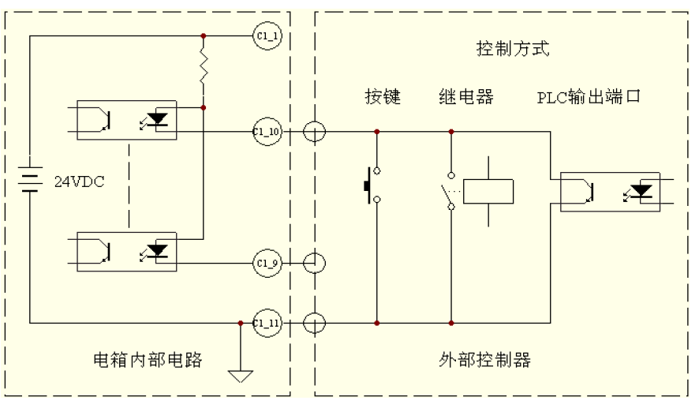

Relay

external control

Generator inside circuits

PLC output port

Press button

Control mode

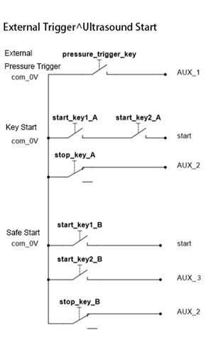

## 8.2 Working Status Output Port

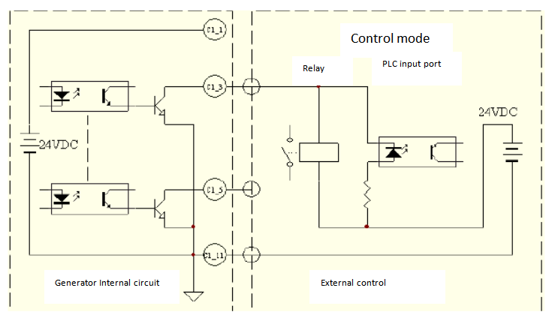

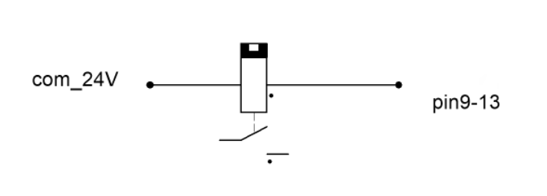

**Attention:** The maximum driving current for 24V power supply input is 1A.

Signal cables shall be screened type with diameter ≥0.3mm2, length shall not exceed 6 meters.

## 8.3 Analog Quantity Input/Output Port

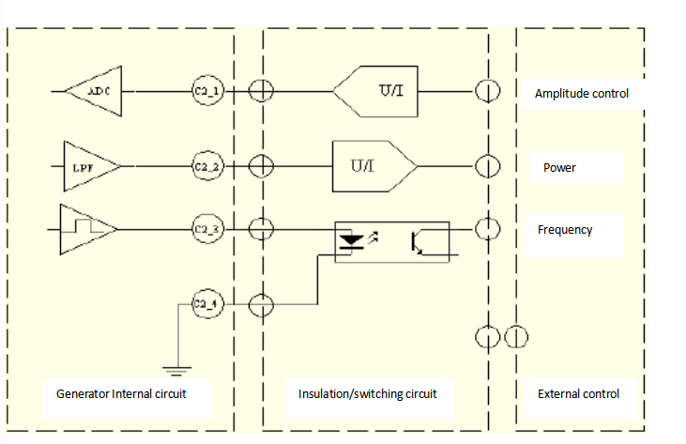

**Attention:** analog input and output ports shall be equipped with insulated switching circuit, and the frequency port is 3.3V/10mA electrical level output.

## 8.4 Communication Port

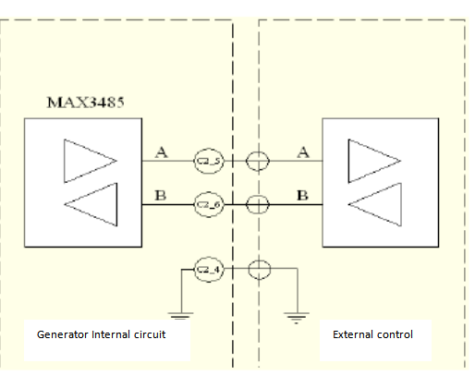

**Attention:** RS485 communication port shall be insulated and the twisted-pair wire shall be screened in strong interference place.

# 9. MODBUS PROTOCOL（MODBUS_RTU,8/N/1,）

## 01H function code：Reading coil status

IP type：0x，IP scope 0x0--0x5.

0x3：Horn Adjustment

0x4：Trigger calibration

0x5：Clear count to zero

0x0：US working

0x1：Frequency search

0x2：US test

## 9.2 02H Function code：Reading input status

IP type: 1x, scope:1xX1000-1xX1015

1x0: Run status 1x8: data error

1x1: trigger cycle data reading 1x9: suspected bad quality

1x2: Emergency stop 1x10: over-heated

1x3: Ready 1x11: abnormal load

1x4: cooling or cylinder action 1x12: Exceed the protection limit

1x5: ultrasonic work status 1x13: welding horn resistance too big

1x6: exceed work limit 1x14: exceed frequency limit

1x7: alarm for malfunction 1x15: exceed power limit

**9.3** **03H function code: Reading save register**

IP type: 4x, Scope:4x0-4x33

4x0: amplitude mode 4x11: shake off delay

4x1: amplitude segment A 4x12：shake off time

4x2: amplitude segment B 4x13: work time of amplitude segment A

4x3: shake-off amplitude 4x14: work energy of amplitude segment A

4x4: run mode 4x15: quality mode

4x5: trigger mode 4x16: lower limit of time for quality calibration

4x6: Delay time 4x17: upper limit of time for quality calibration

4x7: US time 4x18: lower limit of energy for quality calibration

4x8: US energy 4x19: upper limit of energy for quality check

4x9: grounding hold time 4x20: protection sensitivity

4x10: cooling or holding time

4x21: slow start speed

4x22: Energy stop speed

4x23: frequency auto-tuning mode

4x24: frequency search direction

4x25: lower limit for frequency search bandwidth

4x26: upper limit for frequency search bandwidth

4x27: Idle resistance limit

4x28: Peak voltage limit

4x29: factory debug

4x30 lower limit for constant amplitude comparison

4x31:upper limit for constant amplitude comparison

4x32: introduce compensation frequency

4x33: start method

9.4**04H function code: reading input register**

IP type: 3x, scope: 3x0-3x11

3x0: external control amplitude 3x5: real-time frequency

3x1:internal PWM value 3x6:ultrasonic energy(double-bit)

3x2:load resistance value 3x8: ultrasonic period

3x3:amplitude strength value 3x9: quality result

3x4:real-time power 3x10: work times(double-bit)

**9.5** **05H function code: compulsory single coil**

IP type: 0x, scope: 0x0-0x15

**See details for 01H function code.**

**9.6** **06H function code: pre-written single register (support 10H function code)**

IP type: 4x, scope: 4x0-4x33.

See details for 03H function code.

# Power supply

|  |  |  |  |  |  |
| --- | --- | --- | --- | --- | --- |
| **Model** | DS400 | | | | |
| **Power** | 4200W | 3000W | 2200W | 1200W | 1000W |
| **Frequency** | 15KHz | 15KHz  20KHz | 15KHz  20KHz | 20KHz | 35KHz |
| **Voltage** | 220VAC±10% 50-60Hz | | | | |
| **Rated current** | 12.9A | 9.6A | 6.5A | 4.8A | 3.2A |
| **Rated power** | 4000W | 3000W | 2200W | 1200W | 1000W |
| **Peak power** | 5600W | 4200W | 2400W | 1800W | 1500W |
| **Fuse protection current** | 25A | 25A | 20A | 15A | 10A |
| **Environment Temperature** | -10 to +55°C | | | | |
| **Protection grade** | IP 20, IEC 60 529, EN 60 525 | | | | |
| **Air source** | 6-8kg/cm²，clean air | | | | |

# 11. Operation Panel

## 11.1 Password Keyboard, Parameter Keyboard

Password keyboard：the password input keyboard has blue backboard with numbers, backspace, clear, ESC and ENT keys.

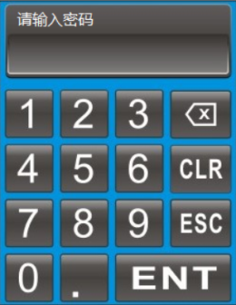

Parameter keyboard: Parameter keyboard has a green backplate with numbers, backspace, CLR (or+/-),ESC and ENT keys.

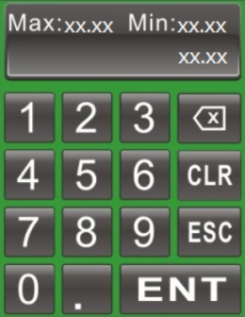

## 11.2 Version Information Page

This page is a default display page when you start the machine. Click any area on this page or just wait for 6s without any action, it will go to weld record page.

This page will display the rated power, rated frequency, version information and date.

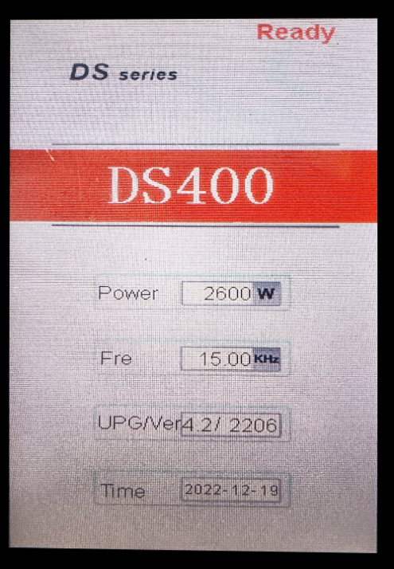

## 11.3 Main Menu

Main Menu is the Menu page-click the corresponding button to enter the corresponding page. Password to each page is:

Protection function: 1962

Amplitude calibration: 8080

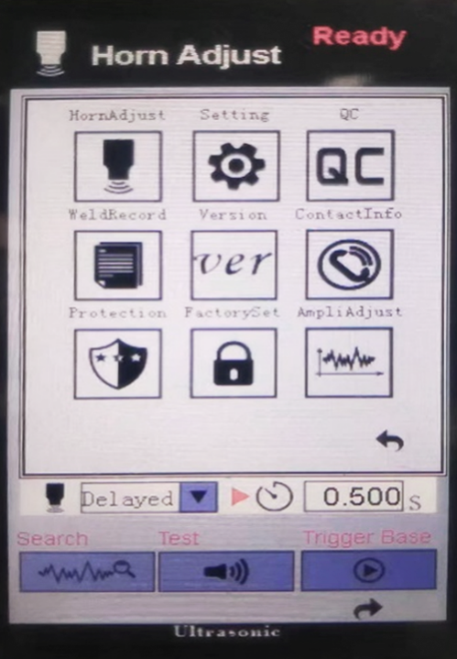Factory setting: 2005

### 

### 11.4 Welding record page

This page displays the welding record, welding power and data management.

Note: Shut down the machine 40s later after the welding done to prevent the loss of the welding data.

Click “Welding record” button to enter Data Management menu. Click any button as per your demand.

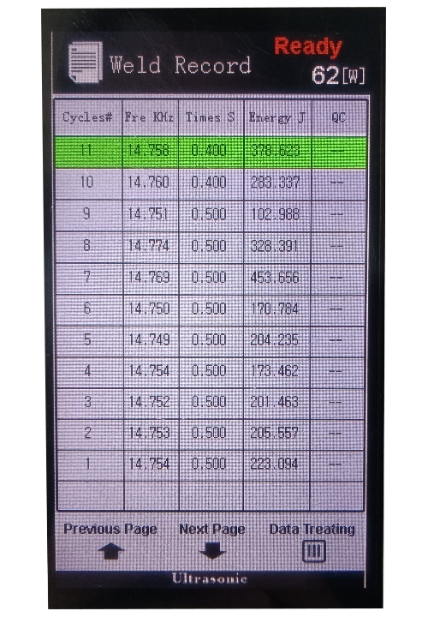

## 11.4.1 Data Management

## CLR：Counting starts from 1, (not recoverable) and the data in the record table will not be deleted.

## Delete record：Delete data in the record table (not recoverable), the counting number cannot be changed.

## Data export： Plug in a USB flash disk, click this button and the history data in the table and scanned data will be exported to the USB flash disk.

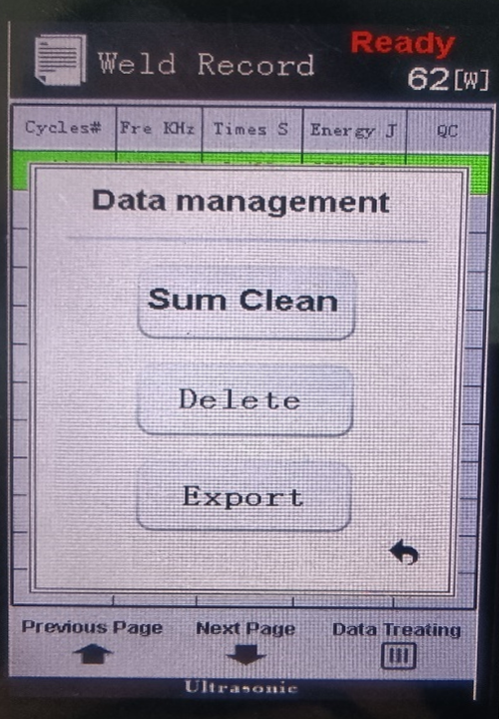

### 

### 11.5 Trigger preparation page

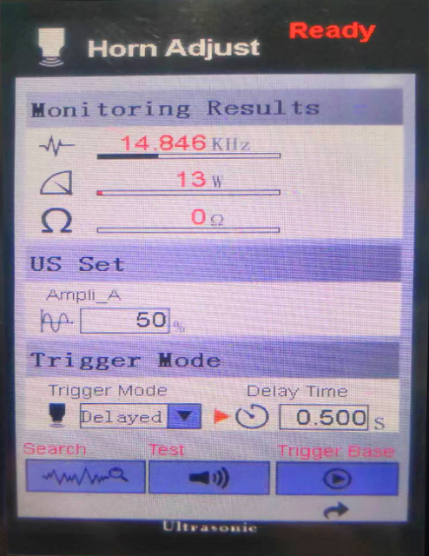This page is for commissioning, you can observe the power, frequency, real-time impedance and some pre-settings, and also you can choose the amplitude, and trigger mode according to the real situation and applications. When it goes into this page during operation of the machine, the machine will stop operation and change from Auto Mode into Manu mode, and when you press the external Emergency button or trigger preparation on the page, it will be recovered (reset).

### 11.5.1 Functions and Parameter Ranges

**Trigger mode selection:**

1 Delayed trigger: Vibration will be delayed 0-10S.

2 Pressure trigger: External pressure switch

**Frequency tracking:** to search real-time frequency (short press type, turns into green while working)

**Sonic testing:** ultrasound function testing (long press type, turns into green while working)

**Trigger base：**when starting it, the machine head goes down to the trigger position and gives out ultrasound and returns automatically.

**Auxiliary mode:** Customized per needs.

## 11.6 Parameter Setting Page

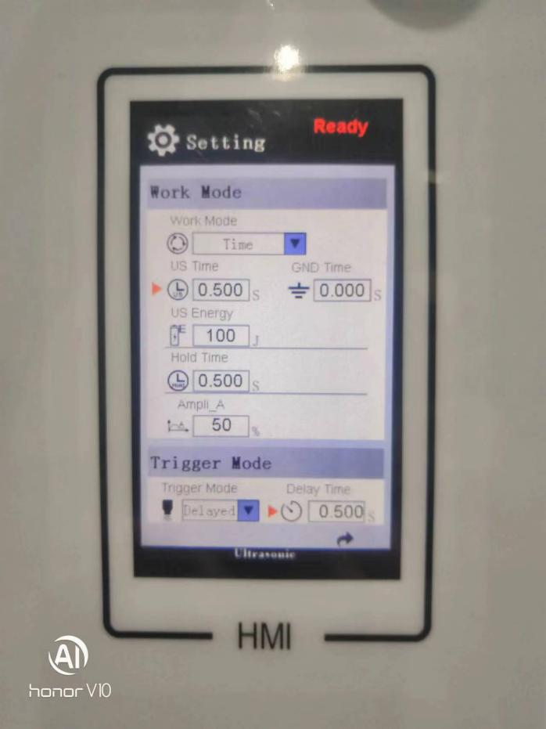 

On this page, the trigger mode, work mode and other parameters can be chosen and set.

11.6.1 **Amplitude mode:**

1. **Fixed:** single amplitude mode (only amplitude Segment A can be displayed; setting scope: 10-100%；
2. **Segmentation：**double amplitude modes, Amplitude Segment/Stage A and Segment/Stage B and the proportion of Segment A can be displayed.

**Setting scope:** Segment A: same as Fixed mode;

Segment B: 10-100%；

Stage A proportion: 10-100%.

**Note：**Segment B proportion will not be displayed, because Segment B proportion is “100%-Segment A proportion“

**Trigger mode:** Same as Trigger Preparation page.

**Run mode:**

Ⅰ.Time: Weld time 0-10S；

Ⅱ.Energy: Weld energy 0-6000J；

Ⅲ.Time+Energy；

IV. GND (External), 0-10s.

**Hold time：**0-10S after welding.

**Shake-off amplitude：**After cooling, the secondary ultrasonic vibration amplitude is 10-100%。

**Shake-off delay：**Secondary ultrasonic vibration delay time is 1-10S.

**Shake-off time：**Secondary ultrasonic vibration time is 1-10S, when it is set at 0S, secondary ultrasonic vibration is stopped.

## 11.7 QC Management Page

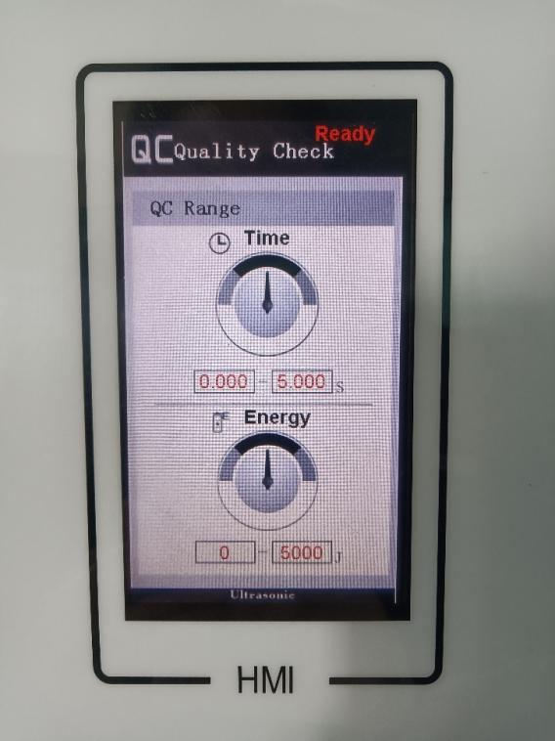

Through this interface, you can turn on/off the corresponding quality management switch and set the quality monitoring range.

**Time Min：**0-Max/S.

**Time Max：**Min-10/S.

**Energy Min：**0-Max/J.

**Energy Max：**Min-60000/J.

**Note：**When the Min. Value is Zero, please set the Max. Value first.

## 11.8 Protection Function Page

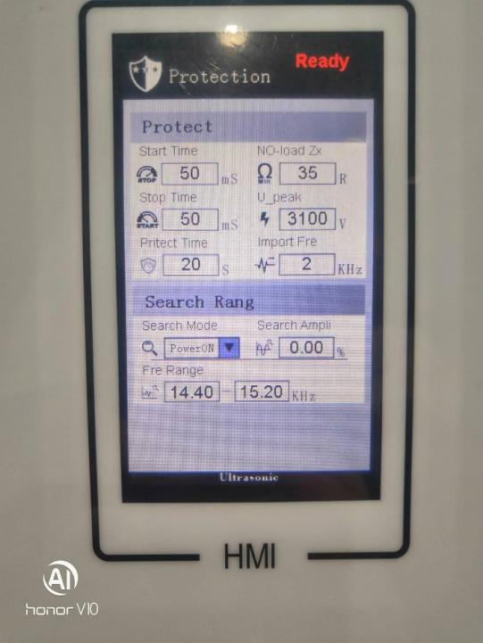

This page is to set the corresponding parameter, password is: 1962.

**11.8.1 Function and Parameter Range**

**Low start speed:** 10-2000mS. The value is bigger, the slow start time is longer. For those welding tools that are not easy to vibrate, this value can be increased properly.

**Phase lock speed：**high speed, quick speed, medium speed, low speed, phase lock rate.

**Auto-searching：**disable, enable, 1 time/min, 3 times/min, 5times/min, 7times/min, 9times/min. Auto-tuning without loading, Compensating frequency deviation due to increased temperature.

**Searching amplitude:** 0-1%.

**Searching bandwidth Min：**0-13KHz.

**Searching bandwidth Max：**Min-70KHz.

**Slow start speed:** 10-2000mS. The value is bigger, the shutoff speed is slower.

**Protection speed:** 1-100Ms.For the responding speed for work protection, the smaller the value is, the more sensitive of the protection is.

For the occasional protection action, please increase this value.

**Peak current:**1-25A.

**Peak voltage:** 500-4000V.

**Impedance limit without load:** 15-100Ω.

**Frequency deviation:** 0-99Hz.

## 11.9 Factory Setting

Click Factory setting to enter into this page, password is: 2005.

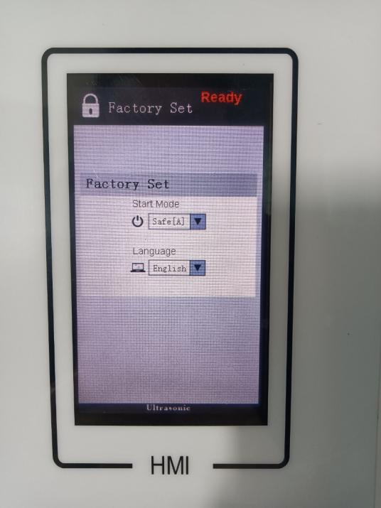

**11.9.1 Factory setting page**

**Start mode:** key, PLC, safe

**Language:** Chinese, English

## 11.10 Amplitude calibration

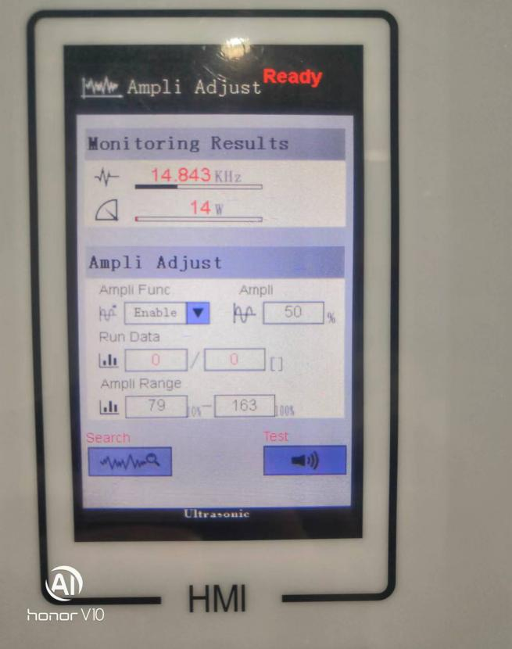

Click Amplitude Adjustment to enter into this page. The password is “8080”.

**Commissioning steps for constant welding:**

1. Select constant welding function and adjust it；

2. Set amplitude at 100%；

3. Long press on ultrasonic TEST button；

4. Watch system parameter and Constant Amplitude Range；

5. Input the Minimum and Maximum value you have seen within the Constant Amplitude Range;

6. Select ENABLE for the constant amplitude.

恒振幅

**11.10.1 Functions and Parameter setting**

**Frequency search:** same as Trigger preparation page.

**Ultrasonic test:** Same as Trigger preparation page.

**Constant Amplitude function:** Enable, Adjust, Disable

**Constant Amplitude Range Min：**20-Max

**Continuous Amplitude Range Max：**Min-999.

# 12. Trouble Shooting

**Ⅰ. Faulty communication**

**Causes:**

Communication cables are not connected soundly；

Communication chips on the control board damaged;

Power source is not stable.

**Solutions：**

Check communication cables connection and plugs;

Change the control board;

Turn on the machine again to reset.

**Ⅱ.Function is limited**

Causes：

Users adjusted the control board or other

applications without permission of the supplier;

Wrong parameter setting；

Faulty initialization of the system data saving.

**Solutions：**

Contact supplier;

Reset the setting data.

**Ⅲ. Low welding quality**

**Causes:**

Suspected bad quality products.

**Solutions：**

Press Emergency button to reset, check workpieces, tools and equipment, and find the problem.

**Ⅳ.Over-heated**

**Causes：**

Radiation fan damaged or the wind channel is blocked；

Welding horn impedance is too high,

resulting in extremely high output power.

**Solution**：

Change cooling fan and check the hot wind channel;

Check welding horn and start ultrasonic generator

to see if the impedance is too high.

**Ⅴ.Abnormal load**

**Causes:**

Converter connection cables are loose or disconnected;

Converter is moisturized or error connection of

the positive and negative poles.

**Solutions:**

Press RESET key to search the frequency；

Check converter and connection cables.

**Ⅵ．Frequency out of range**

Causes：Welding horn temperature is getting higher that lead to the deviation of the frequency and exceeding the maximum work limit;

Welding horn gets loose or damaged that lead to non-resonance of the frequency.

**Solutions：**

Press RESET button to search frequency；

Cooling down the welding horn to normal scope；

Check the welding horn, start ultrasonic system to judge if the horn impedance is normal.

**Ⅶ．Overload Power**

**Causes：**

Output power exceeds the allowed power scope.

**Solutions：**

Press RESET button to search frequency；

Decrease amplitude or reduce the load

(such as to reduce the air pressure)；

Change to higher power ultrasonic generator.

**Ⅷ．Voltage and Current too high**

**Causes：**

The peak voltage on both ends of the converter exceeds the allowed scope；

Welding horn impedance is too high or load is too high.

**Solutions:**

Press RESET button to re-search the frequency;

Check the welding horn and start ultrasonic system to check if the horn impedance is normal;

Decrease the amplitude or reduce the load (such as to reduce the air pressure)；

For the protection action that sometimes happens, you can increase the protection sensibility properly;

For the protection action that often happens, you can increase the “Peak voltage “value properly.

**Ⅸ．Welding horn impedance is too high**

**Causes：**

Impedance of welding horn exceeds allowed scope；

During ultrasonic test, the load is too high(for example,

test starts when the welding horn presses on the workpieces).

**Solutions：**

Press RESET button to re-search frequency;

Check the welding horn and revise it；

Conduct ultrasonic test without load；

For the test with load (such as ultrasonic shaped charge rod)，you can increase the “idle impedance limit” value.

**Ⅹ.Abnormal Data**

**Causes:**

Code scanner scanned the same data as previous one.

**Solutions：**

Scan the code again；

Check the workpiece labels to see if they are same.

**Note：** If above solutions cannot solve your problems, please contact us.

# 13. Quality Guarantee

**The following statement has to be observed for quality guarantee：**

**Warranty scope:**  12 months since purchase for the machine, 3 months for welding horns.

If the malfunction happens due to following reasons, the maintenance has to be paid even it is in warranty period:

Problem due to incorrect operation or repairing without our permission；

Problem due to application exceeding the standard;

Damage due to falling down or moving with violence after purchase;

Using our equipment in the environment that does not confirm with the requirement in this user’s manual, which results in aging of the components or other malfunction；

Foreign materials go inside the machine (such as bugs) , which results in the damage of the machine；

Incorrect cable connection resulted in damage of the machine;

Malfunction caused by earthquake, fire, wind or flood, thunder, abnormal voltage or other natural disasters.

# 14. Additional Information

Declaration of exempt of liability;

1.Any liability caused by using our products while violating the regulations in this user’s manual, will not be born by our company.

2.Any loss or involvement of loss, consequent damage caused by using our machines will not be our responsibility to compensate such a loss or damage.

# 15. Contact us

Company Name：K&M Technologies LTD

Website：[www.plasticjoining.net](http://www.plasticjoining.net) / [www.knmsonic.com](http://www.knmsonic.com)

Email: mfrlucy@vip.163.com

TEL：0086 512 57403727

Technical service hotline：0086-15850300139