上海标星科技发展有限公司

K&M Technologies Ltd.

Standard Type Ultrasonic

Welding Equipment

DS400

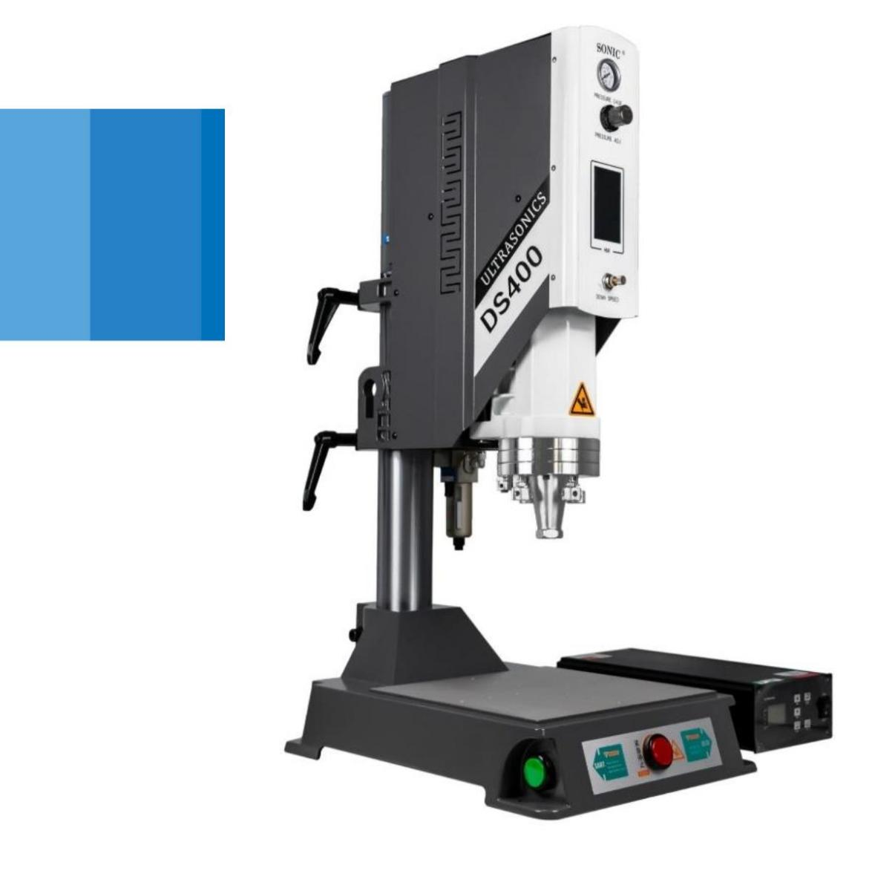

上海标星科技发展有限公司

K&M Technologies Ltd.

K&M TECH: Standard ultrasonic

welding machine for universal application

In order to meet customers' more personalized needs, we launched the ultrasonic

plastic welding machine DS400 series (DS300 upgraded version) in the second

half of 2020.

★ The DS400 series are also

equipped with a new generation of

digital ultrasonic generator and a

4.3-inch touch screen to achieve

visual operation and control of field

operations with the operating

system.

★ While

maintaining

the

high

efficiency, easy to use, stability and

economic characteristics of the

original series of products, nearly

20 improvements have been made

on the structure, material, safety

and color of the whole machine,

casting a new generation of basic

entry-level hot style products

**Generator**

**Start Button**

**Air Filter**

**Rotary Handle**

**Speed Regulator**

**4.3 inch Interface**

**Air Pressure Meter**

**Transducer**

**Level Screw**

**Pressure Regulator**

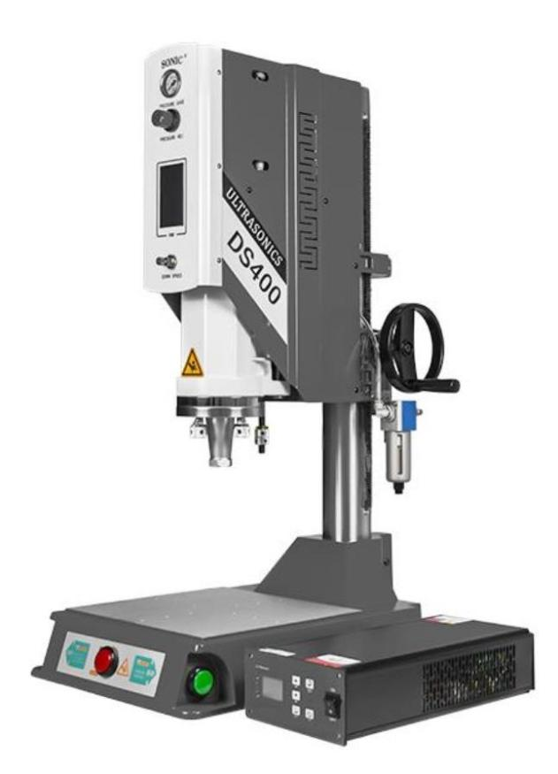

上海标星科技发展有限公司

K&M Technologies Ltd.

K&M TECH: Standard ultrasonic

welding machine for universal application

Mechanical Features

▶Digital circuit system: real-time frequency automatic tracking and locking display;

▶Three ultrasonic welding mode: Time mode; Energy mode; Grounding Mode;

▶ Quadruple intelligent management: Amplitude management; quality

management; data management; safety management;

▶ Abundant models and accessories: Products cover 15K-35kHz frequencies and

1000W-4000W powers.

▶The addition of split design and level control system can meet the requirements of

most on-site welding scenes.

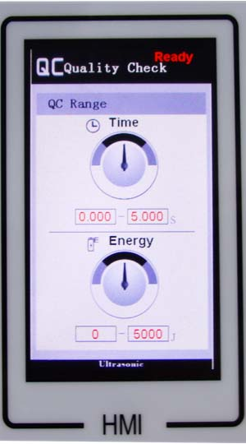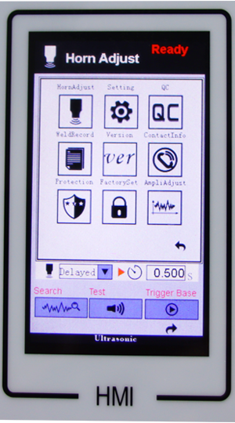

**Main Menu**

**QC Menu**

**User Interface:**



上海标星科技发展有限公司

K&M Technologies Ltd.

K&M TECH: Standard ultrasonic

welding machine for universal application

Technical Data:

|  |  |
| --- | --- |
| **Technical Data** | |
| Power supply voltage | AC 220V 50/60Hz |
| Working frequency | 15/20/35kHz |
| Output Power [W] | 4200W/3000W/2200W/1200W/1000W |
| Welding Time | 0.01-9.999 Seconds |
| Working stroke [mm] | 75mm |
| Air pressure rate[MPa] | 0-0.6MPa |
| Weight [kg] | 85KG |
| Amplitude Internal | 60-100 at 5% steps |

Available Models:

|  |  |  |  |  |  |
| --- | --- | --- | --- | --- | --- |
| **Frequency** | **Rated Power** | **Rated Current** | **Work Stroke** | **Voltage** | **Air Source** |
| 15kHz | 4200W | 12.9A | 75MM | 220VAC±10%  50-60Hz | 6-8kg/cm²，  clean air |
| 15kHz | 3000W | 9.6A |
| 15kHz | 2200W | 6.5A |
| 20kHz | 3000W | 9.6A |
| 20kHz | 2200W | 6.5A |
| 20kHz | 1200W | 4.8A |
| 35kHz | 1000W | 3.2A |



上海标星科技发展有限公司

K&M Technologies Ltd.

K&M TECH: Standard ultrasonic

welding machine for universal application

Ultrasonic welding application:

For all application markets, ultrasonic welding has its unique advantages - fast,

Efficient, clean and firm, won the recognition of all walks of life.

Home Appliances:

Automobile:

n . through appropriate adjustment can

n . ultrasonic wave can be controlled by

computer program to implement the welding of

large and irregular parts. such as bumpers,

front and rear doors, lamps, brakes

be used for: portable lamp shade,

steam Ironing door, TV shell, radio,

transparent panel, power rectifier,

n. the screw fixing seat of TV shell, the lamp

housing for reducing mosquitoes and the sink

for washing machine etc.. which need to be

sealed and firm and beautiful home

appliances.

n . Lamp, etc. With the development of high-

grade roads, reflectors are also increasingly

using ultrasound wave soldering.

Packaging:

Toy Industry:

n.hose

sealing,special

packaging belt connection.

n . the adoption of ultrasonic technology makes

the products clean and efficient, firm, instead

of screws, adhesives, glues or other

accessories, reducing the risk & production

cost, so that the competitiveness of

enterprises in the market greatly enhanced.

Electronics:

n.use automation scheme design to enable

users to achieve large-scale production.

n . At the same time ensure product quality

requirements.

Other Commercial Application:

n.communication equipment,computer industry,

printing equipment, Audio products, can be

welded by K&M ultrasonic equipment, which

brought you fast, clean, efficient production

methods, and more opportunities.

