

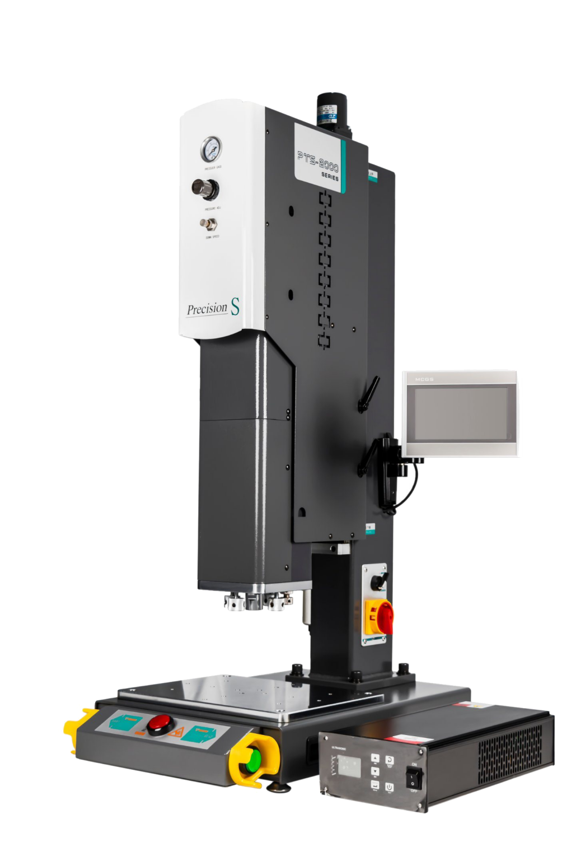

**Advanced Type Ultrasonic**

**Plastic Welding**

**Equipment**

**PTS2000**



**K&M TECH: Advanced Ultrasonic**

**Welding machine for universal application**

As the backbone of the ultrasonic welding machine products, this series of products integrate a variety of precision control techniques, including

★ Welding machine balancing system,

★ Horizontal adjustment system,

★ Linear slide rail lifting system,

★ Micrometer positioning system,

★ Mechanical pressure sensors

to meet the requirements of the complex welding work environment and diverse needs of customers.

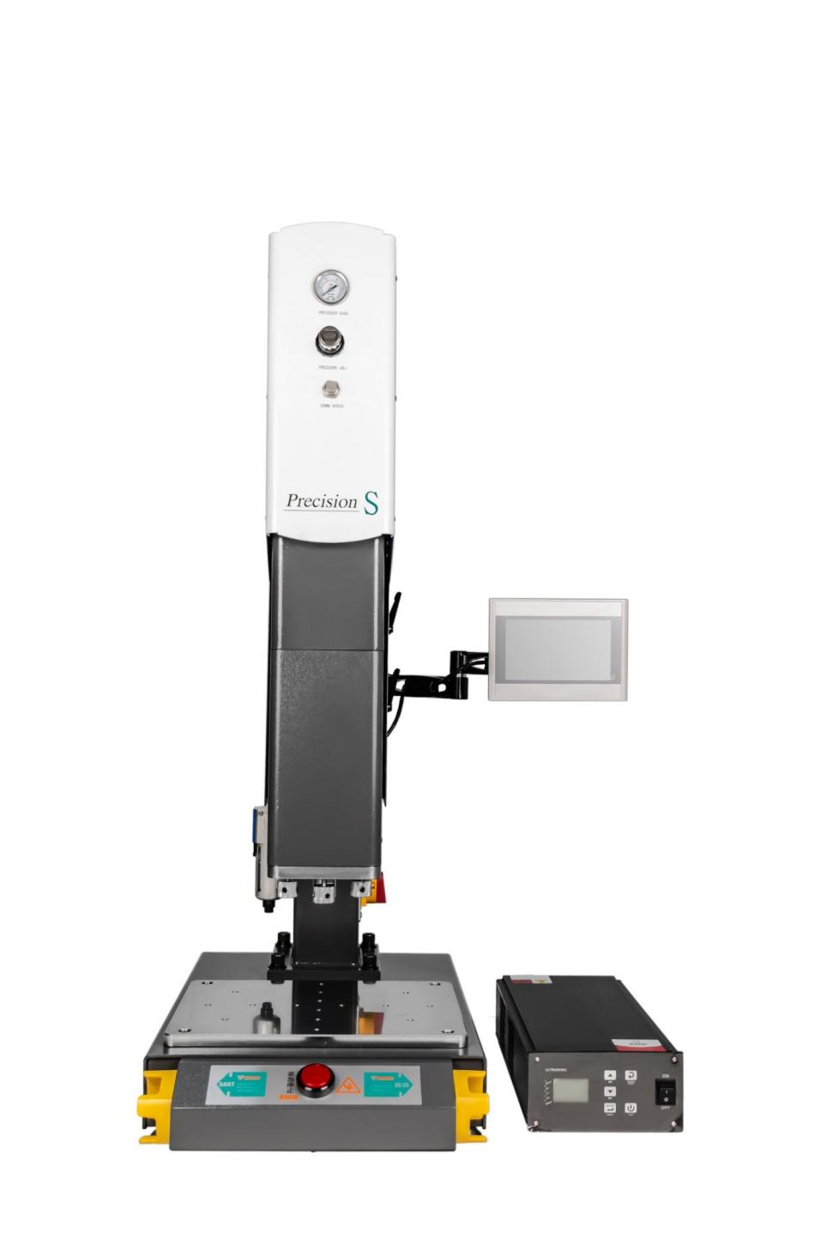

**Air Pressure Meter**

**Pressure Regulator**

**Speed Regulator**

**Lock Handle**

**User Interface**

**Lock Handle**

**Level Screw**

**Generator**

**Emergency Button**

**Start Button**

**K&M TECH: Advanced Ultrasonic**

**Welding machine for universal application**

**Mechanical Features:**

▶ Automatic frequency tuning  to each welding stack used  (no frequency teaching required).

▶ Automatic frequency tuning  before starting each weld.

▶ Automatic amplitude stabilization throughout the operation.

▶ Setting and automatic modes  (password protection >> user level).

▶ Data storage for many freely  nameable parameter sets.

▶ "Welding force", "amplitude", "time", "welding depth" and  "monitoring value" parameters input via the touchscreen  display.

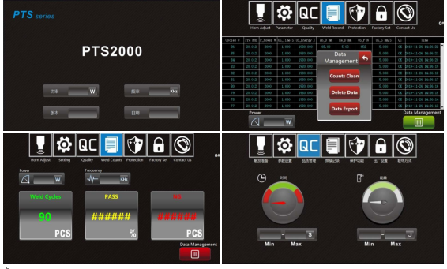

**K&M TECH: Advanced Ultrasonic**

**Welding machine for universal application**

**Technical Data:**

|  |  |
| --- | --- |
| **Technical Data** | |
| Power supply voltage | AC 220V 50/60HZ |
| Frequency | 15/20/35KHz  35Khz |
| Output Power  [W] | 1000W-4200W  1200W |
| Language: | Chinese/English |
| Work Stroke | 75/100mm |
| Processor: | 4-core, 32-bit processor, 485 communications |
| Welding mode | Time, Energy, Time+Energy |
| Depth Check: | 0.01mm precision |
| Interface: | 7-inch Human-machine interface |
| Energy Mode | Integrated |
| Time Mode | 0.005-9.999 Seconds |
| Welding amplitude: | 10~100% adjustable (1% accuracy) |

**Available Models:**

|  |  |  |  |  |  |
| --- | --- | --- | --- | --- | --- |
| **Frequency** | **Power** | **Work Stroke** | **Lifting Mode** | **Voltage** | **Air Source** |
| 15kHz | 2200W | 75MM | electric control | 220V±10% | 2kgf-8kgf |
| 15khz | 3000W | 75MM |
| 15khz | 4200W | 100MM |
| 20kHz | 1200W | 75MM |
| 20kHz | 2200W | 75MM |
| 20kHz | 3000W | 75MM |
| 35KHz | 1000W | 75MM |

**Ultrasonic welding application:**

**K&M TECH: Advanced Ultrasonic**

**Welding machine for universal application**

For all application markets, ultrasonic welding has its unique advantages - fast, Efficient, clean and firm, won the recognition of all walks of life.

### Automobile:

n.ultrasonic wave can be controlled by computer program to implement the welding of large and irregular parts. such as bumpers, front and rear doors, lamps, brakes

n.Lamp, etc. With the development of high- grade roads, reflectors are also increasingly using ultrasound wave soldering.

### Packaging:

n.hose sealing,special packaging belt connection.

### Electronics:

n.use automation scheme design to enable users to achieve large-scale production.

n.At the same time ensure product quality requirements.

### Home Appliances:

n.through appropriate adjustment can be used for: portable lamp shade, steam Ironing door, TV shell, radio, transparent panel, power rectifier,

n.the screw fixing seat of TV shell, the lamp housing for reducing mosquitoes and the sink for washing machine etc.. which need to be sealed and firm and beautiful home appliances.

### Toy Industry:

n.the adoption of ultrasonic technology makes the products clean and efficient, firm, instead of screws, adhesives, glues or other accessories, reducing the risk & production cost, so that the competitiveness of enterprises in the market greatly enhanced.

### Other Commercial Application:

n.communication equipment,computer industry, printing equipment, Audio products, can be welded by K&M ultrasonic equipment, which brought you fast, clean, efficient production methods, and more opportunities.