Capwall |  | 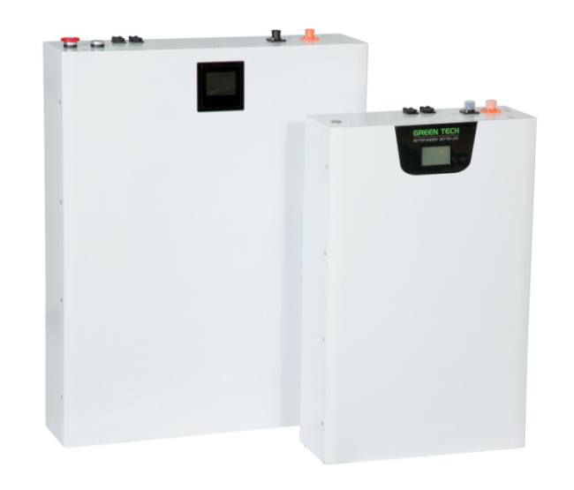
FEATURES
* EM series battery cells
* Safest technology
* Ultra long cycle life
* Extreme temperature
* Wall mountable
* Rarely maintenance
PART NUMBER | GTEM-48V15K-W2
Energy storage | 15kWh
Capacity | 294Ah
Nominal Voltage | 51.8V/DC
Maximum Charge Voltage | 58V/DC
Discharge Cut-off Voltage | 42V/DC
Internal Configuration | 14S14P/EM21
ESR/AC @1KHz 50% SOC | <15mΩ
Max. Continuous Charge Current | 200A
Max. Continuous Discharge Current | 200A
Cells Self-discharge Rate | 2% per month
Round Trip Efficiency*¹ | 97.5%
Projected cycle life(25℃) | 20000 times
Projected life(25℃) | 15 years
Recommended Depth of Discharge | ≤90%
Maximum Depth of Discharge | 100%
Cooling Method | Natural
Shell Material | Metal & ABS plastic
Parallel Connection | Up to 16 sets
Compatible Protocol | CAN,RS485
Monitoring Data | System voltage,current,temperature,SOC,SOH,cycle,cell’s voltage
ENVIRONMENTAL SPECIFICATIONS
Ingress Rating | Indoor IP20
Operating Humidity | 0~90% RH Non-condensing
Charge Temperature | 0℃~+55℃
Discharge Temperature | -20℃~+60℃
Storage Conditions | SOC>30%,-20℃~+40℃,25% ~ 95%RH,  One full charge needed per two months
Transport Conditions | 50% SOC,-20℃~+40℃
Maximum Elevation | 3000m (9843ft)

COMPLIANCE INFORMATION
IEC*² | IEC62619
Italy | CEI0-21:2022
CE | EN 62133:2013,  EN 55032:2015+AC:2016,  EN 55035:2017,  EN 61000-3-2:2014,
Transport | UN38.3,MSDS
Environmental | RoHS
Remark:*¹ (1)At room temperature 25℃, charge-discharge at 100A.(2)Limited charge at 100A for resident energy storage, (3)At the beginning of life. *²on testing,certificate will come soon.

MECHANICAL SPECIFICATIONS
Part Number | GTEM-48V15K-W2
Weight | 132Kg
Dimensions(WxHxT) | 700x765x175(mm)
Mount Options | Wall mountable
Dimensions and weight differ slightly for each batch. Contact Green Tech for additional information.
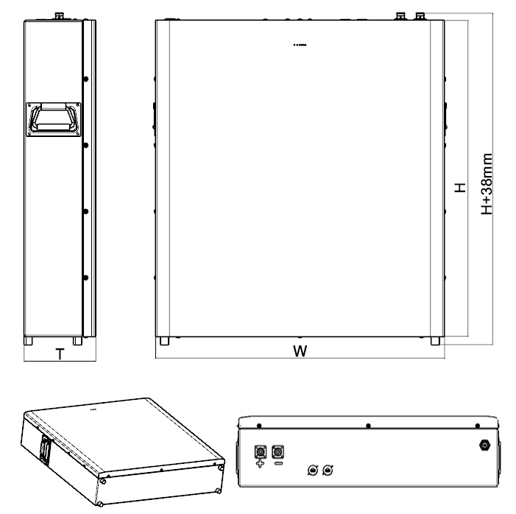

CHARGING-DISCHARGING CURVE

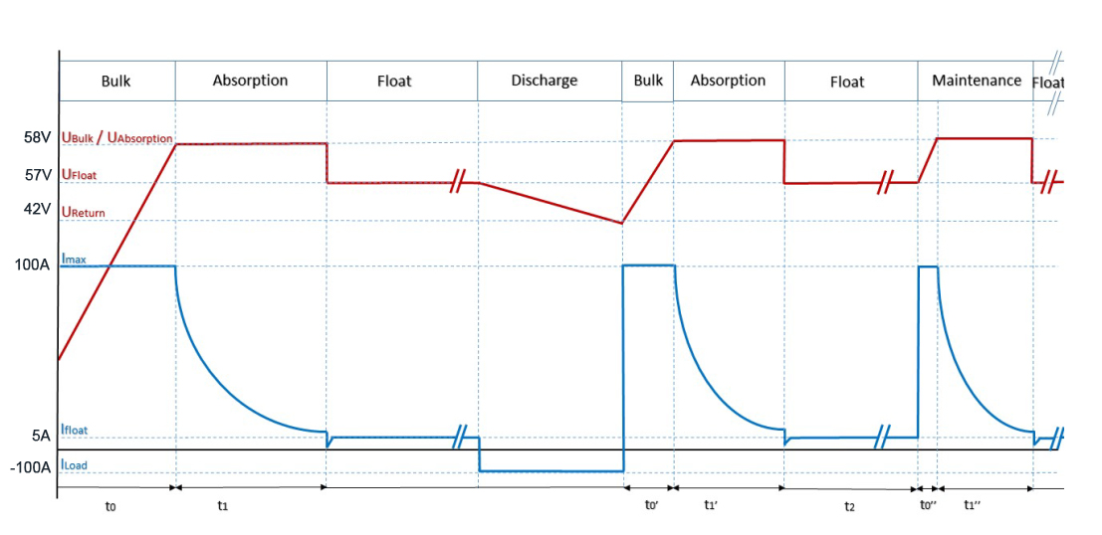

200A

200A

Note：If the charger needs to set the floating charge voltage, it is recommended to set the U Float value to 57V.
Bluetooth Display Function
This Bluetooth APP can be operated by both Android and IOS. It establish a Bluetooth connection between your smart phone and the battery, usages includes below: managing the battery pack, gathering the data and
displaying them, conducting modifications on settings.
Bluetooth APP can achieve below functions:
- Display the basic data of battery pack
- Modifying the communication between BMS and inverter
- Setting Alert Parameters and Switch on/off
- Support Single and Parallel operation
- Shift between Chinese and English

