

**HOP-H801** **Thermal** **Receipt** **Printer**

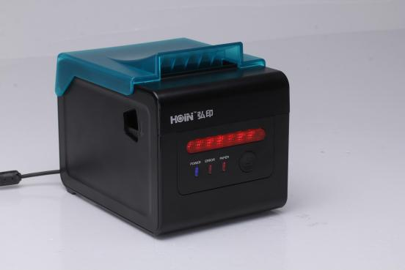

**Product** **description:**

HOP-H801 is a high-end and well-designed thermal receipt printer. 300MM/S high-speed printing . It have oil-proof cover to ensure excellent waterproof, oil-proof and dust-proof performance; It have front LED lights to remind you of the incoming orders, paper lacking, error notice etc in noisy environments; It have paper detection function for untaken bill by flashing lights and alarming sound; Printer have wire cable hidden slot and wall hanging function. Rich interface optional: USB,Ethernet,COM,Bluetooth,Wi-Fi. Large input buffer, to avoid losing any bills . Hoin Leading technology brings you a high-quality and stable printing experience.

**Product** **performance:**

●300 mm / second ultra high-speed printing, improve the printing efficiency

● Front LED lights remind you of incoming orders, paper lacking, error notice etc.

● Paper detection function for untaken bill by flashing lights and alarming sound

● Excellent waterproof, anti-oil, anti-dust structure design

●Wire cable hidden slot can avoid the damage which come from splashing oil or splashing water ●Support wall hanging function, meet the special environment printing

● Movable baffle design, support 80MM, 58MM different width of the paper roll printing

●Support kitchen printing and Internet printing

● Using 100M Ethernet card, connect printer faster, to avoid losing bills

● Recover printing after network disconnection,to avoid losing bills

●Support LOGO Graphical download and print

●Support 1D,2D bar code printing

●Support order come remind and error alarm

●Support Multi language printing

●Compatible with ESC/POS print instruction mode

●Support Windows,Linux,Android iOS and Mac system



**Application:**

Shopping malls, restaurants, stores, warehousing, taxation, banking, medical, postal

**Printer** **Parameters:**

|  |  |  |
| --- | --- | --- |
| Item | | Parameters |
| Print parameters | Printing Method | Thermal Line |
| Printing width | 72mm |
| Resolution | 576 Dots/Line or 512 Dots/Line（8dots/mm，203dpi） |
| Print speed | 300mm/s(Max) |
| Interface | USB/Ethernet/COM/Bluetooth/Wi-Fi Optional |
| Line Spacing | 3.75mm（Can adjust line spacing by command） |
| Line No. | FontA-48Lines/FontB-64Lines |
| Character | Standard GB18030 simplified,BIG5 traditional Chinese Fonts and Japanese (Korean optional) |
| Character Size | ANK character，Font A：1.5×3.0mm（12×24 dots）  Font B：1.1×2.1mm（9×17 dots） |
| Bar code Character | Extended character set | PC437/Katakana/PC850/PC860/PC863/PC865/WestEurope/Greek/Hebrew/EastEurope/Iran/WPC1252/PC866/PC852/PC858/IranII/Latvian/Arabic/PT151,1251/PC737/WPC/1257/ThaiVietnam/PC864/PC1001/(Latvian)/(PC1001)/(PT151,1251)/(WPC1257)/(PC864)/(Vietnam)/(Thai) |
| Bar code | 1D bar code：UPC-A/UPC-E/JAN13(EAN13)/JAN8(EAN8)CODE39/ITF/CODABAR/CODE93/CODE128  2D barcode：QRCODE |
| Graphics printing | Graphics printing | Supports bitmap download and print |
| Cutter | Cutter Function | Full cut/Half cut |
| Paper | Type | Thermal |
| Width | 80mm or 58mm |
| Diameter | ≤80mm |
| Feed method | Easy feed(Clamshell feed) |
| Print commands | Commands | ESC/POS |
| Power | Power Adaptor | Input：AC 100V-240V,50-60Hz  Output：DC 24V/2.5A |
| Cash Drawer Output | DC 24V/1A |
| Buffer | Input Buffer | 2048K bytes |
| NV Flash | 256K bytes |
| physical characteristics | Weight | 1.5KG (Pure printer weight without package) |
| Dimension | 195*145*143(MM) |
| environment | Working | Temp：5 ~ 45℃， Humidity：10 ~ 80% |
| Storage | Temp：-10 ~ 50℃ ，Humidity：10 ~ 90%（No dew） |
| Reliability parameter | Print Head Life | 150KM（print density≤12.5） |
| Cutter Life | 1500,000times |
| Software | System | Windows,Android,iOS,Linux,Mac |