HOP-E804 Thermal Receipt Printer
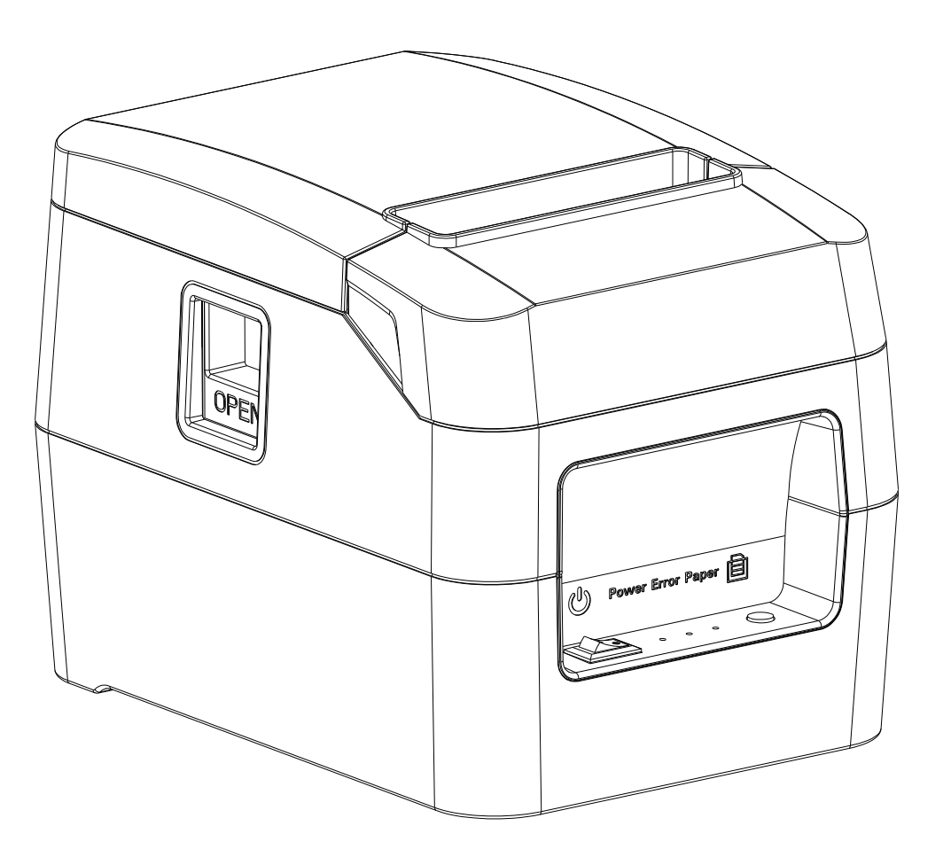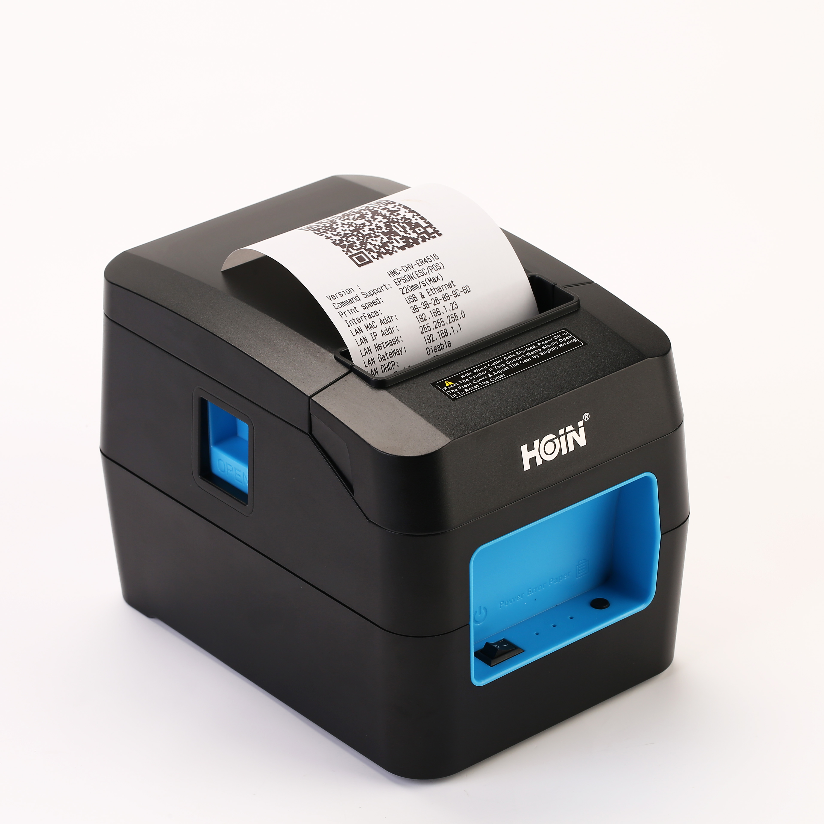

Product description:
HOP-E804 is a newly designed thermal receipt printer with high reliability and high performance and cost effectiveness. 220mm/s high speed printing; Rich interface selection including USB,Internet,Bluetooth,WIFI; Real-time printing monitoring function, to avoid losing any bills with great extent,creating a enjoyable and extraordinary printing experience.
Product performance:
●220mm/s high speed printing;
●Support wall hanging function, meet the special environment printing;
●Support printer monitoring function,to avoid losing bills;
●Using 100M Ethernet card, Printing more fast and fluently.
●Re-printing after network disconnection,to avoid losing bills;
●Support LOGO Graphical download and print;
●Support 1D,2D bar code printing;
●Support order come remind and error alarm;
●Support Multi language printing;
●Rich InterfaceUSB/Ethernet/COM/Bluetooth/Wi-Fi Optiona(Interface combination, pls contact manufacture to confirm)
●Support Windows,Linux,Android iOS and Mac system;
Application:
Shopping malls, restaurants, stores, warehousing, taxation, banking, medical, postal

Printer Parameters:
Item |  | Parameters
Print parameters | Printing Method | Thermal Line
Print parameters | Printing width | 72mm
Print parameters | Resolution | 576 Dots/Line or 512 Dots/Line（8dots/mm，203dpi）
Print parameters | Print speed | 220mm/s(Max)
Print parameters | Interface | USB/Ethernet/COM/Bluetooth/Wi-Fi Optional
Print parameters | Line Spacing | 3.75mm（Can adjust line spacing by command）
Print parameters | Line No. | FontA-48Lines/FontB-64Lines
Print parameters | Character | Standard GB18030 simplified,BIG5 traditional Chinese Fonts and Japanese (Korean optional)
Print parameters | Character Size | ANK character，Font A：1.5×3.0mm（12×24 dots）  Font B：1.1×2.1mm（9×17 dots）
Bar code Character | Extended character set | PC437/Katakana/PC850/PC860/PC863/PC865/WestEurope/Greek/Hebrew/EastEurope/Iran/WPC1252/PC866/PC852/PC858/IranII/Latvian/Arabic/PT151,1251/PC737/WPC/1257/ThaiVietnam/PC864/PC1001/(Latvian)/(PC1001)/(PT151,1251)/(WPC1257)/(PC864)/(Vietnam)/(Thai)
Bar code Character | Bar code | 1D bar code：UPC-A/UPC-E/JAN13(EAN13)/JAN8(EAN8)CODE39/ITF/CODABAR/CODE93/CODE128  2D barcode：QRCODE
Graphics printing | Graphics printing | Supports bitmap download and print
Cutter | Cutter Function | Full cut/Half cut
Paper | Type | Thermal
Paper | Width | 79.5±0.5mm
Paper | Diameter | ≤80mm
Paper | Feed method | Easy feed(Clamshell feed)
Print commands | Commands | ESC/POS
Power | Power Adaptor | Input：AC 100V-240V,50-60Hz  Output：DC 24V/2.5A
Power | Cash Drawer Output | DC 24V/1A
Buffer | Input Buffer | 24K bytes
Buffer | NV Flash | 256K bytes
physical characteristics | Weight | 0.9KG (Pure printer weight without package)
physical characteristics | Dimension | 185*133*133(MM)
environment | Working | Temp：5 ~ 45℃， Humidity：10 ~ 80%
environment | Storage | Temp：-10 ~ 50℃ ，Humidity：10 ~ 90%（No dew）
Reliability parameter | Print Head Life | 100KM（print density≤12.5）
Reliability parameter | Cutter Life | 1000,000times
Software | System | Windows,Android,iOS,Linux,Mac

