HOP-E801 Thermal Receipt Printer
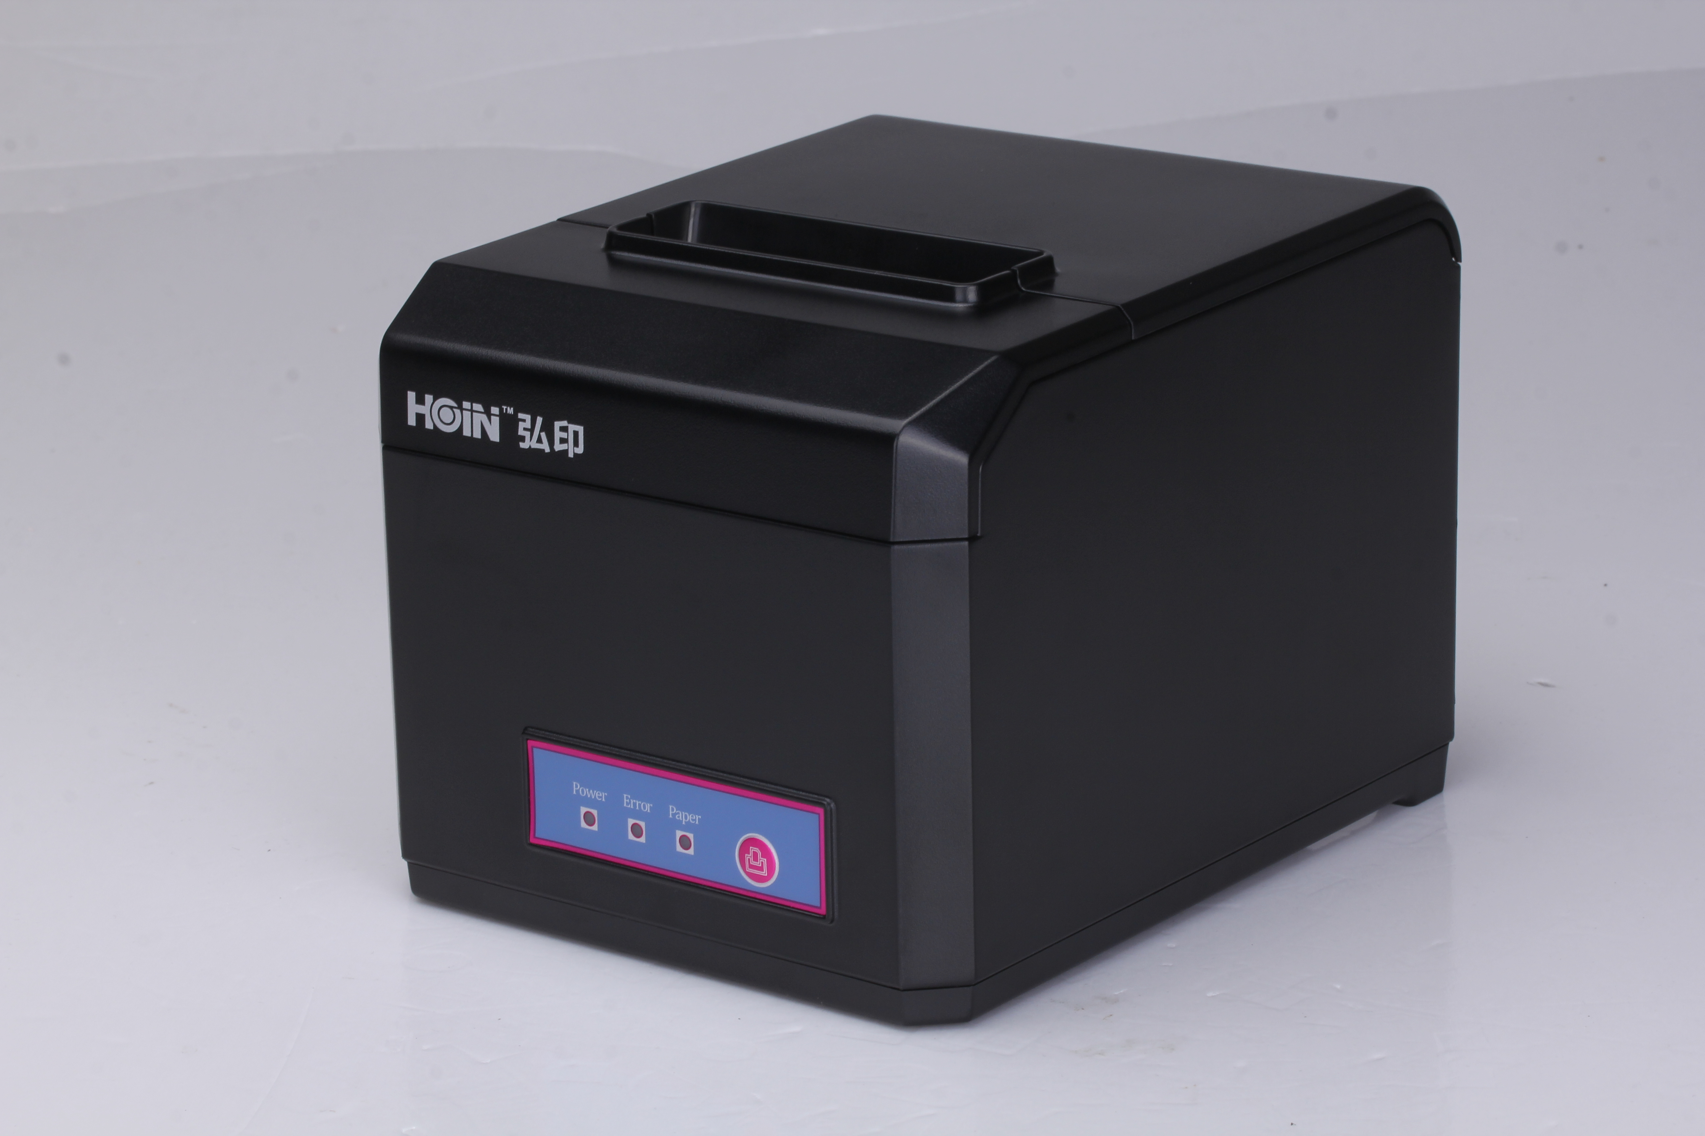
Product description:
HOP-E801 is a high quality HOIN brand thermal printer which designed for network and kitchen printing. 300MM/S(Max) high speed printing; excellent waterproof, oil proof, dust proof structure design; rich interface options including USB,LAN,,Bluetooth,Wi-Fi. Real-time monitoring function and large input buffer can avoid bills losing. Leading technology with high performance make sure a high-quality, worry free printing experience.

Product performance:
●300 mm / second(Max) ultra high-speed printing, improve the printing efficiency;
●Excellent waterproof, anti - oil, anti-dust structure design;
●Support wall hanging function, meet the special environment printing;
●Movable baffle design, support 80MM, 58MM different width of the paper roll printing;
●Support 80MM large diameter roll;
●Support kitchen printing and Internet printing;
●Support printer monitoring function,to avoid losing bills;
●Using 100M Ethernet card, connect printer faster, to avoid losing bills;
●Recover printing after network disconnection,to avoid losing bills;
●2048K super input buffer,to avoid losing bills;
●Support LOGO Graphical download and print;
●Support 1D,2D bar code printing;
●Support order come remind and error alarm;
●Support re-print;
●GB18030 Large font;
●Support Multi language printing;
●Rich Interface:USB/Ethernet/COM/Bluetooth/Wi-Fi Optional
●Compatible with ESC/POS print instruction mode;
●Support Windows,Linux,Android ,iOS and Mac system;
●Speed::300mm/s（Max）
Application:Shopping malls, restaurants, stores, warehousing, taxation, banking, medical, postal

Printer Parameters:
Item |  | Parameters
Print parameters | Printing Method | Thermal Line
Print parameters | Printing width | 72mm or 64mm
Print parameters | Resolution | 576 Dots/Line or 512 Dots/Line（8dots/mm，203dpi）
Print parameters | Print speed | 300mm/s(Max)
Print parameters | Interface | USB/Ethernet/COM/Bluetooth/Wi-Fi Optional
Print parameters | Line Spacing | 3.75mm（Can adjust line spacing by command）
Print parameters | Line No. | FontA-48Lines/FontB-64Lines
Print parameters | Character | Standard GB18030 simplified,BIG5 traditional Chinese Fonts and Japanese (Korean optional)
Print parameters | Character Size | ANK character，Font A：1.5×3.0mm（12×24 dots）  Font B：1.1×2.1mm（9×17 dots）
Bar code Character | Extended character set | PC437/Katakana/PC850/PC860/PC863/PC865/WestEurope/Greek/Hebrew/EastEurope/Iran/WPC1252/PC866/PC852/PC858/IranII/Latvian/Arabic/PT151,1251/PC737/WPC/1257/ThaiVietnam/PC864/PC1001/(Latvian)/(PC1001)/(PT151,1251)/(WPC1257)/(PC864)/(Vietnam)/(Thai)
Bar code Character | Bar code | 1D bar code：UPC-A/UPC-E/JAN13(EAN13)/JAN8(EAN8)CODE39/ITF/CODABAR/CODE93/CODE128  2D barcode：QRCODE
Graphics printing | Graphics printing | Supports bitmap download and print
Cutter | Cutter Function | Full cut/Half cut
Paper | Type | Thermal
Paper | Width | 80mm or 58mm
Paper | Diameter | ≤80mm
Paper | Feed method | Easy feed(Clamshell feed)
Print commands | Commands | ESC/POS
Power | Power Adaptor | Input：AC 100V-240V,50-60Hz  Output：DC 24V/2.5A
Power | Cash Drawer Output | DC 24V/1A
Buffer | Input Buffer | 2048K bytes
Buffer | NV Flash | 256K bytes
physical characteristics | Weight | 1.15KG (Pure printer weight without package)
physical characteristics | Dimension | 186*145*135(MM)
environment | Working | Temp：5 ~ 45℃， Humidity：10 ~ 80%
environment | Storage | Temp：-10 ~ 50℃ ，Humidity：10 ~ 90%（No dew）
Reliability parameter | Print Head Life | 150KM（print density≤12.5）
Reliability parameter | Cutter Life | 1500,000times
Software | System | Windows,Android,iOS,Linux,Mac

