Specification Sheet

 TGW-FH001D Full-height Turnstile

( Double-Channel ) Full-height Turnstile

**Function:**

1) Unique two-way anti-reverse function.

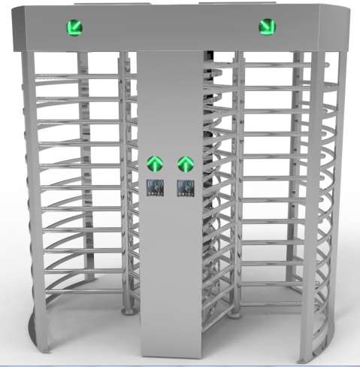2) Programmable device's operating status through the built-in small press plate on control board

3) Anti-rushing function ,when the gate signal is not received, the turnstile arms locked automatically

4) The center rotor will be set free (default) or locked (optional) automatically when the power is off.

5) Automatic Reset Functions: after you swap the card, during the specific time (the system is 10s)

6) The turnstile can work with door access control system/ consumption system /ticket system/biometric recognition system/ ESD system and so on

7) Can be unidirectional or bidirectional control of personnel access.

8) Can manager and long-range control the turnstile directly by managing the computer

**Extensible functions:**

1. LED counter display

2. Casing and gate size can be lengthened

3. Light,sound alarm

**Dimensional drawing:**

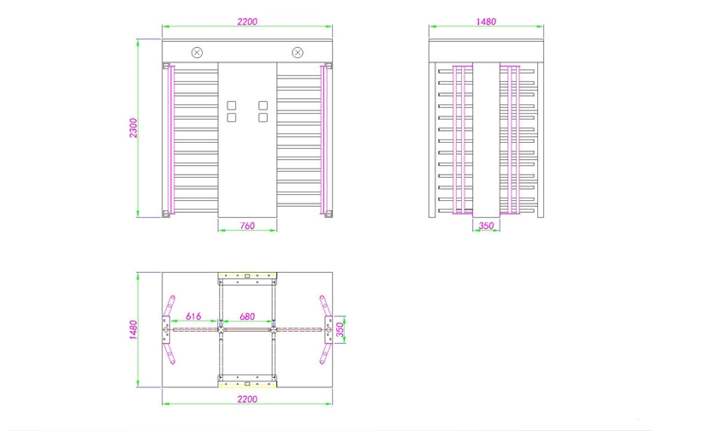

**Parameters:**

|  |  |
| --- | --- |
| Cabinet Material | 304 Stainless Steel |
| Dimensions | 1450*2300*2300mm |
| Weight | 150KG |
| Channel | Single |
| Blades | 3/4pcs |
| Rod Length | ≤510mm |
| Angel | ≤90/120 degree |
| Opening Signal | Relay |
| Material Thickness | 1.5mm |
| Card-reading Window: | Two |
| Protection function | Infrared anti-pinch,Break-in alarm function |
| Direction | Bi-directional |
| Service Life | 5million times |
| Operating Temperature | -25℃ ~ +60℃ |
| Related Humidity | ≤90%RH |
| Communication Interface | TCP/IP |

**Application:**

Full height turnstile

1. Can be compatible with face recognition,IC card,ID card,bar code card,fingerprint reading card recognition device.
2. Used for staff, provide civilized,orderly access methods,effectively manage the access of staff .
3. Can be widely used in some high security places, such as prison, stadium, parking system area , and so on.